**ADJECTIVE PHRASE DIAGRAM TREE STRUCTURE IN ROSIE'S SOLO ALBUM BY ROS****É**

By:

Kheisya Syifa Azzahra

Sekolah Tinggi Bahasa Asing (STBA) JIA

[kheisyasam09@gmail.com](mailto:kheisyasam09@gmail.com)

Abstract

This Research is aimed to help other to understand about the structure of adjective phrase through Rosie solo album by Rosé. The writer chooses this album as the object of this analysis is because one of the songs from this album, which were “APT” featuring with Bruno Mars become a hit and is No. 1 on Billboard Global for 5 weeks. The data were analyze using Burton-Roberts (2016) tree diagram theory on Analysing sentences: An introduction to English syntax book. It use qualitative research method with a descriptive analysis. The research found five adjective phrases (AP) inside of Rosie album by Rosé’s songs which are “Number One Girl”, “3am”, and “Too Bad for Us”. Out of the five data, the adjective phrases (AP) which used pre-modifier the most with five pre-modifiers, while the post-modifier only two.

Kata kunci: Adjective phrase, Burton-Roberts, Rosie, Rosé, tree diagram

1. **INTRODUCTION**

In linguistics, there is a structural analysis named linguistics level. It is a structure where you analyze focusing on one aspect at a time. There are four aspects in linguistics level, which are phonology, morphological, syntactic level, and semantic level (Katamba 1993, p.4). Syntax, according to Matthews (1981, p.1), is a branch of grammar which deals with how words are arranged within a sentence so it could have connections and meaning. On easy terms, it could be deciphered that syntax is a study of branch grammar that focuses on sentence structures. It means that syntax study about grammar is more in-depth, because it explains how a sentence, phrase, and clause could be the way they were.

In terms of analysing a sentence structure, Burton-Roberts (2016, p.7) stated that it is usual to use a diagram for analyzing sentence structures, which were called the tree diagram. It is a diagram with a function of analysing linguistics’ expression, to identify the component of a word, and then determining their function inside a sentence.

**Picture 1.** Example of Tree Diagram from Burton-Roberts’ Book (p.22)

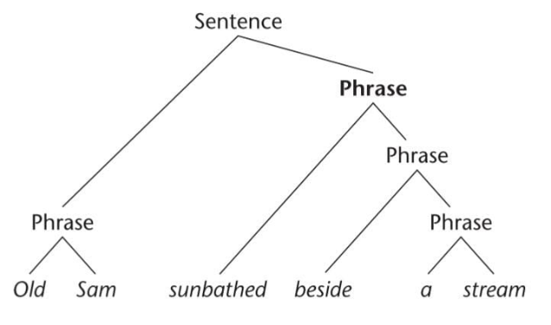

As it could be seen from Picture 1 above, the tree diagram shows a hierarchical structure of a sentence “Old Sam sunbathed beside a stream”. It marks the component that completes the sentence, which are phrases. The phrases are a mediator for the sentence and the word to be able to become one as a single unit.

Phrases, according to Burton-Roberts (2016, p.12) is a group of word that has a function of a component or constituents’ sentence (S) structure. In grammar, there are five types of phrases (Nelson, G., & Greenbaum 2013, S p.65), which are noun phrase (NP), verb phrase (VP), adjective phrase (AP), adverb phrase (AdvP), and Prepositional Phrase (PP).

**Table 1.** Component structure of sentence and phrase

|  |  |
| --- | --- |
| **Sentence and Phrase** | **Component Structure** |
| 1. Sentence (S) | NP + [Auxilary (AUX)] +VP |
| 1. Noun Phrase (NP) | [Determiner (DET)] + [AP] + N + [PP] |
| 1. Verb Phrase (VP) | V + [NP] + [PP] + [Adv.P] |
| 1. Prepositional Phrase (PP) | P + NP |
| 1. Adjective Phrase (AP) | A + [PP] |

[…] *means it is optional to be inside a phrase or sentence*

For this paper analysis, the writer will only focus on adjective phrase structure because it is relevant with the problem that the writer is facing.

Based on Burton-Roberts (2016, p84), Adjective phrase is a compilation of words which consist adjective as its main words. For the structure, it usually consists of these elements of structure:

**Picture 2.** Element Structure of Adjective Phrase from Nelson, G. & Greenbaum (p.84)

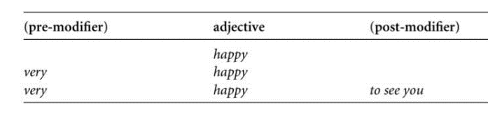

Based from Picture 2, it could be said that modifiers denoted the adjective and it was optional to be on adjective phrase. There are two modifiers for this phrase, there are pre-modifier and post-modifier. The possible structure of this phrases could be described like these:

**Picture 3.** Possible Structure of Adjective Phrase (Nelson, G. & Greenbaum 2013, p.85) using tree diagram (Burton-Roberts, 2016)

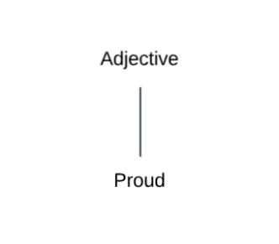

**Picture 4.** Possible Structure of Adjective Phrase (Nelson, G. & Greenbaum 2013, p.85) using tree diagram (Burton-Roberts, 2016)

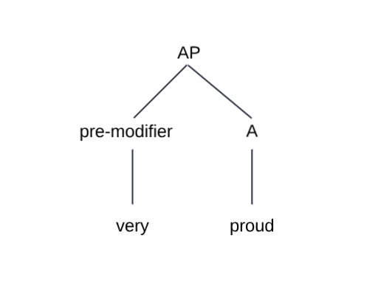

**Picture 5.** Possible Structure of Adjective Phrase (Nelson, G. & Greenbaum 2013, p.85) using tree diagram (Burton-Roberts, 2016)

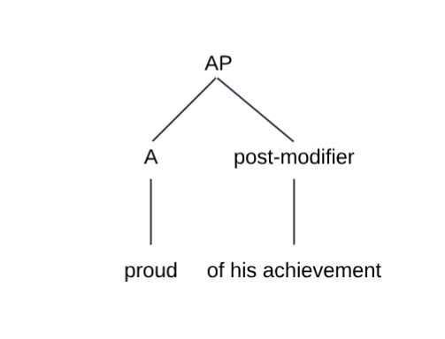

**Picture 6.** Possible Structure of Adjective Phrase (Nelson, G. & Greenbaum 2013, p.85) using tree diagram (Burton-Roberts, 2016)

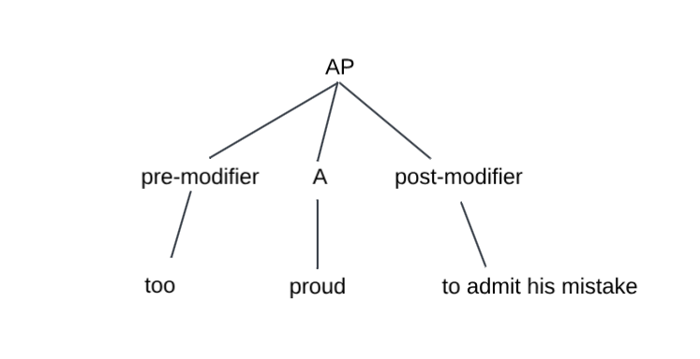

Pre-modifier on AP means for degree adverb. According to EF (n.d), degree adverb is a used of words to tell us about the intensity of something. For degree adverb, there are “too”, “very”, “quite”, “almost”, and “extremely”. While post-modifier on AP meant for prepositional phrase (PP).

Adjective phrases on a sentence had functions such as:

* + - 1. Pre-modifier in a noun phrase
      2. Subject complement
      3. Object complement
      4. Post-modifier in a noun phrase

With only focusing on adjective phrase structure, the writer believe that she will be able to distinguish the phrases on the object that she will analyze, which are Rosie album by Rosé.

According to Genius (n.d), Rosie is Rosé’s debut studio album which were released on 6th of December 2024. It consists of 12 songs, with “APT” ft. Bruno Mars as its first single released, “Number One Girl” as its second, and “Toxic till the End” as it third. Other than these three songs, there is also “3am”, “Two Years”, “Drinks or Coffee”, “Gameboy”, “Stay a Little Longer”, “Not the Same”, “Call it the End”, “Too Bad for Us”, and “Dance All Night”. For the purpose of this research paper, the writer will use three songs from the album, which are “Number One Girl”, “3am”, and “Too Bad for Us”. Then she will analyze the lyrics which possessed adjective phrase and give it a through-out explanations.

The writer chooses this album as the object of this analysis is because one of the songs from this album, which were “APT” featuring with Bruno Mars become a hit and is No. 1 on Billboard Global for 5 weeks. Other than that, it is because Rosé has been the writer role model ever since she was in junior high school.

Another research which was used as a reference for this paper are “An Analysis Phrase Structure Rules in Anneth Song Lyrics” by Rahmawati R., Gaol, S. P. L., Hutabarat, N. D. B., & Pandiangan, T. (2022). It is research with a purpose to distinguish type of phrase and the rule of phrase in Anneth’s song lyrics. Not only that, this is also a study to know the level of SMP Adventist 2 Medan students’ understanding about phrases.

1. **RESEARCH METHODOLOGY**
2. **Method of the Research**

The research of this paper is qualitative research. According to Creswell (2012), as cited on Puspahaty & Musta’innah (2023), the qualitative research method had a descriptive trait because it involved how the process, meaning, and understanding is collected on words or picture and not number. It could be concluded that the process of the research will consist of the process of data collecting, the data analysis which focuses on specific problems, and the result of the research based on the writer's interpretation with the help of the theory analysis.

1. **Time and Place of the Research**

This paper research started at the 30th of December 2024. there is no specific place to do the research since it used qualitative research and the writer could execute it anywhere. Usually, the research paper was done at the writer's home and sometimes at STBA JIA.

1. **Setting of the Research**

The setting of this research used Rosé first full-length album called Rosie. To be specific, the writer chooses three of the songs to analyze the lyrics, which are “Number One Girl”, “3am”, and “Too Bad for Us”.

1. **Technique of the Data Collection**

To collect the data, the writer will listen to all of the songs from the album one by one and read the lyrics thoroughly at the same time. After finding the existence of the adjective verb inside the lyrics, the writer then will write it down so it could be analyzed later on.

1. **Technique of the Data Analysis**

To analyze the data, the writer will used Burton-Roberts’s (2016) theory about phrase structure, where it will used diagram tree to analyze the phrase structure word by word. With doing this, we could see the classification of the word and it will be easier to understand.

**Example 1.** Analyzing with Tree Diagram

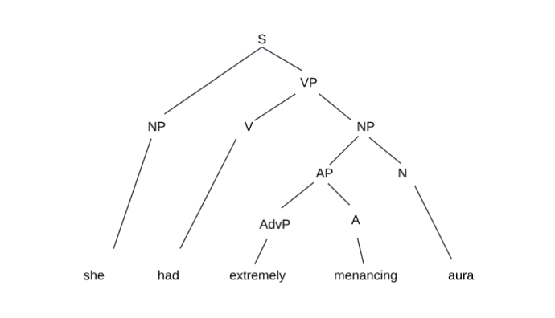

1. **Instrument of the Research**

Because this paper used qualitative research method, the instrument for this paper would be the writer herself. The writer will analyze the data based on the theory that is already mentioned above and will give the best and deeper reasoning.

1. **RESEARCH FINDINGS AND DISCUSSIONS**

The research finding of this paper will use the lyrics of the songs from Genius website (n.d), where it will use the lyrics from “Number One Girl”, “3am”, and “Too Bad for Us”. The writer will observe the lyrics thoroughly and chose a specific lyrics which contain adjective phrase, after that she will analyze the phrase structure with tree diagram (Burton-Roberts, 2016) and give a reasonable explanation. There will be five data that the writer will analyze. Whereas there will be two data from “Number One Girl”, one data from “3am”, and two data from “Too Bad for Us”.

* + - 1. **Datum 1**

Lyrics: “Tell me I’m going **real big places**” – Number One girl

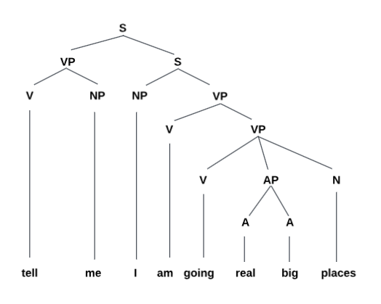

Based from the tree diagram of the sentence above, there is one **adjective phrase (AP)** from the verb phrase (VP) “going real big places”. If we break down the sentence (S) structure, the phrase rule structure would be:

S**➝** VP + S

While the pattern of the phrase rule structure would be:

S**➝** VP + S, VP**➝** V + NP, S**➝** NP + VP, VP**➝** V + VP, VP**➝** V + **AP** +N, **AP➝** **A + A**

Inside the verb phrase (VP) “going real big places”, the phrase **“real big”** act as a modifier or an **adjective** for the noun phrase (NP) “places”. Where as the both word **“real”** and **“big”** is an **adjective**.

* + - 1. **Datum 2**

Lyrics: “**down to earth, so friendly**” ­– Number one girl

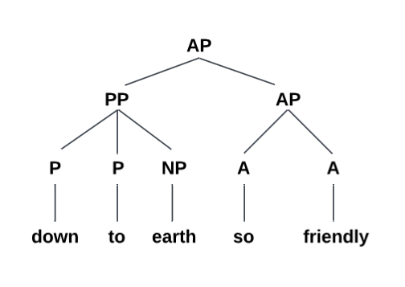

The root of this phrase **is adjective phrase (AP)** because it is expressing the quality of something. The phrase structure rules of this phrase is:

AP**➝** PP + AP

The pattern of the phrase rule of this phrase would be:

**AP➝ PP + AP,** PP**➝** P + P + NP, **AP➝ A + A**

The first branch or the phrase “down to earth” is classified as a prepositional phrase (PP), even though it is an idiom for being humble and it’s function as an **adjcetive**.It is because the class of the word inside it is a noun phrase (NP) modified by prepositions. While the second branch or “so friendly” is an **adjective phrase (AP)** due to the word “so” and “friendly are both an adjective.

* + - 1. **Datum 3**

Lyrics: “I need you really really **that bad**” – 3am

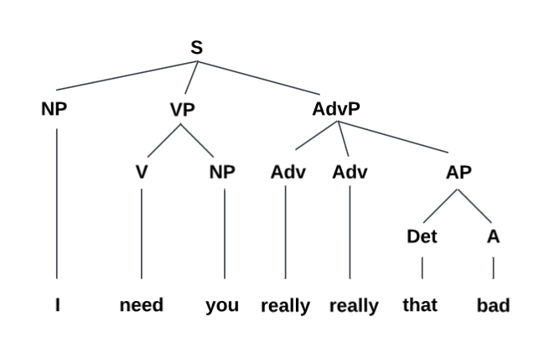

As the tree diagram showed above, there are one **adjective phrases (AP)**.The phrase structure rules for this sentence are:

S**➝** NP + VP + AP

While the phrase rules’ pattern for this sentence is:

S**➝** NP + VP + AP, VP**➝** V + NP, AdvP**➝** Adv + Adv + **AP**, **AP➝ Det + A**

The **adjective phrase (AP)** in this sentence, modified by adverb phrase (AdvP) is functioning as a modifier for the noun phrase (NP) “you”. It was to highlight the complexity of the expresion in the sentence with the degree of need.

* + - 1. **Datum 4**

Lyrics: “and that’s **just too bad for us.**” – Too Bad for Us

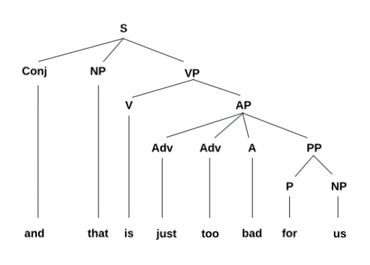

For this sentence, it could be seen from the tree diagram that there is one **adjective phrase (AP)**. The phrase rule structure would be:

S**➝** Conj + NP + VP

The pattern of phrase rule of this sentence is:

S**➝** Conj + NP + VP, VP**➝** V + **AP**, **AP➝ Adv + Adv + A + PP**, PP**➝** P + NP

The function of the **adjective phrase (AP)** in this sentence is to be describe the degree state of the situation. To be precise, it is to modify the prepositional phrase (PP) situation.

* + - 1. **Datum 5**

Lyrics: “I guess we got **too close**.” – Too Bad for Us

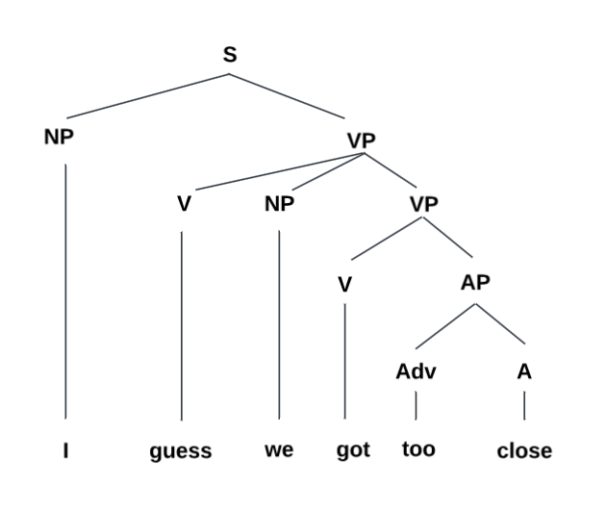

Based from the tree diagram of this sentence (S) above, there is one **adjective phrase (AP)**. For the phrase rule structure of this sentence, it would be:

S**➝** NP + VP

For the pattern of phrase rule structure of this sentence would be:

S**➝** NP + VP, VP V + NP + VP, VP V + **AP**, **AP Adv + A**

The **adjective phrase (AP)** inside this senntence has a function as a modifier to the situation which were happening to the subject (NP).

Based from the research finding above, there are five adjective phrases (AP) inside of Rosie album by Rosé’s songs which are “Number One Girl”, “3am”, and “Too Bad for Us”. Out of the five data, the adjective phrases (AP) which used pre-modifier the most with five pre-modifiers, while the post-modifier only two. Here is the diagram with percentage of the usage between pre-modifier and post-modifier inside the data.

**Figure 1.** Diagram of finding analysis reearch regarding the usage of modifiers inside the APs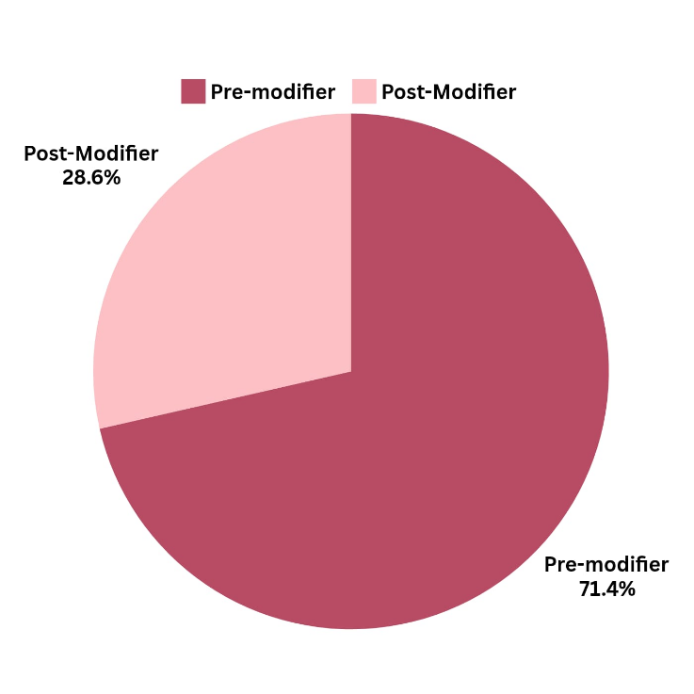

1. **CONCLUSION, IMPLICATION, AND RECOMMENDATION**

**1**. **Conclusion**

After analyzing the five adjective phrase data from Rosie album by Rosé’s song, which were “Number One Girl”, “3am”, and “Too Bad for Us”, pre-modifier was mostly used in the phrase.

2. **Implication**

The writer hopes that with the existence of this paper research, it could help the reader to understand more about adjective phrase, how could the phrase could be called adjective phare, and how to analyze it using tree diagram.

3. **Recommendation**

While analyzing the data, the writer noticed that she often confused noun phrase and adjective phrase. It is because the writer still lack of understanding the difference between the two. To be concluded, it is necessary to learn more deeply about the many types of phrases so confusement would not happen when were trying to differ one type of phrase to another.

**REFERENCES**

Burton-Roberts, N. (2016). *Analysing sentences: An introduction to English syntax*. Routledge.

EF, (n.d). *Adverbs of Degree | EF.* Retrieved on January 19, 2025 from <https://www.ef.com/wwen/english-resources/english-grammar/adverbs-degree/#:~:text=Adverbs%20of%20degree%20tell%20us,examples%20of%20adverbs%20of%20degree>.

Genius. (n.d). *ROSÉ – rosie Lyrics and Tracklist | Genius.* Retrieved on January 15, 2025 from <https://genius.com/albums/Rose/Rosie>

Katamba, F. (1993). *Morphology*. St. Martin’s Press.

Matthews, P. H. (1981). *Syntax*. Cambridge University Press.

Nelson, G., & Greenbaum, S. (2013). *An introduction to English grammar*. Routledge.

Rahmawati, R., Gaol, S. P. L., Hutabarat, N. D. B., & Pandiangan, T. (2022). *An Analysis Phrase Structure Rules in Anneth Song Lyrics.* Indonesian EFL Journal, 8(1), 73-82. Retrieved on January 15, 2025 from <https://journal.uniku.ac.id/index.php/IEFLJ/article/view/5590>