**PREPOSITIONAL PHRASES IN MOVIE "*CORPSE* *BRIDE*": A SYNTAXTIC ANALYSIS OF ANIMATED DIALOGUE**

Oleh

Agil Sabbrina

[agilsabbrina2806@gmail.com](mailto:agilsabbrina2806@gmail.com)

School of Foreign Language JIA

**ABSTRACT**

The writer undertakes a detailed analysis of prepositional phrases in the dialogue of Tim Burton's animated film "*Corpse* *Bride*" (2005). The story revolves around Victor Van Dort, a well-off young man set to marry Victoria Everglot, the daughter of a nobleman from a once-prominent family. While rehearsing his wedding vows in the forest, Victor inadvertently binds himself to Emily, a female corpse who has long been awaiting marriage. Through this analysis, the writer identifies eighteen instances of prepositional phrases within the film's dialogue. Utilizing syntactic analysis informed by Francis Katamba's "*Modern* *Linguistics* *Morphology*" (1st edition), the study explores the various prepositional phrases found in the dialogue, examining their roles and effects on character development and the narrative as a whole. The analysis categorizes these prepositional phrases into five distinct groups: those functioning as locatives, directionals, temporals, intrumentals, and modals.

Keyword: Prepositional phrase, Katamba, Dialog analysis

**A. INTRODUCTION**

A prepositional phrase, often abbreviated as "PP," consists of a preposition combined with its object. This type of phrase serves to add descriptive details about location, time, or specific actions. By using prepositional phrases, we can provide additional information that improves the clarity and understanding of a sentence. For example, in the sentence "My car is in the trunk," the phrase "in the trunk" offers essential context by indicating where the car is located. Prepositional phrases are vital elements of language, enhancing our ability to comprehend sentences and communicate effectively.

In this discussion, I adopt a robust lexicalist perspective as I analyze prepositional phrases through both semantic and syntactic lenses. Specifically, I treat prepositions—along with verbs and nouns—as lexical units that influence their surrounding syntactic structures. In essence, I view them as key factors that shape the internal organization of these structures and facilitate their interaction with other domains. The specific local domain established by a preposition is known as a prepositional phrase (Wunderlich 1991). An alternative perspective suggests that a prepositional phrase functions as a grammatical constituent, much like a noun phrase (NP) or a verb phrase (VP). This means that a prepositional phrase can contain an endless array of additional constituents from the same category. A clear illustration of this concept can be found in the sentence: "John saw the picture of the baby on the table in the attic" (Katamba 2004).

In this study, the writer builds upon the seminal research conducted (Putri and Syarif 2020) This study aims to conduct a similar analysis, but with a different focus. Specifically, it will explore the use of prepositional phrases in the dialogue of the animated film "*Corpse* *Bride*". The objective is to investigate how these phrases contribute to the relationships between the characters in the movie. Additionally, the analysis will examine how the use of prepositional phrases affects the audience's understanding of the narrative and character interactions. Through this research, we hope to provide valuable insights into the role of language in shaping narratives and character development within cinematic works.

**B. METHODOLOGY**

1. **Research Methods**

The aim of this study is to examine and evaluate the use and impact of prepositional phrases found in the film "*Corpse* *Bride*". Unlike previous research, this study takes a unique approach by focusing on a distinct set of elements and exploring various aspects in a new light (Putri and Syarif 2020). The current study utilizes a qualitative descriptive approach, which encompasses a blend of sampling techniques, data collection methods, analysis, and re-presentation. This section outlines the standard design features of this method. Qualitative descriptions are specifically aimed at delivering straightforward answers to inquiries that are pertinent to practitioners and policymakers (Sandelowski 2000).

Qualitative content analysis serves as a powerful tool for examining qualitative descriptive research. This method is notably versatile, enabling the exploration of both verbal and visual data. The primary aim of this analysis is to combine the insights gathered from the data, ultimately enhancing understanding and deepening our knowledge of the subject matter (Altheide 1987). Unlike quantitative content analysis, which relies on numerical data, qualitative content analysis emerges directly from the data itself. This approach entails a systematic application of codes that are generated during the research process. The writer's role involves not only recording the data but also analyzing the findings thoroughly. It is essential for the writer to collect, assess, and confirm the accuracy of these findings. Ultimately, this meticulous process allows the writer to delve deeper into the subject matter and draw well-informed conclusions.

1. **Object or Data**

The writer offers a comprehensive explanation of the data, using insights gained from his analysis of prepositional phrases in the film "*Corpse* *Bride*" with Katamba's theory. Which explains that prepositional phrases are phrases headed by prepositions and contain noun objects and nominal phrases. usually used to indicate place, purpose, time, reason, manner, and other relationships. Which is explained in Katamba's book entitled "*Modern* *Linguistics* *Morphology* (1993)". And the other theory explained about in dealing with prepositional phrases both semantically and syntac-tically, I assume as strong a lexicalist position as possible. In particularI consider prepositions (as well as verbs and nouns) as lexical units whichproject their properties onto a local domain of syntactic structure, thatis, as determining both the internal structure of this domain and thepossibilities of interlocking with other domains. As usual, the localdomain projected by a preposition is called a prepositional phrase (Wunderlich 1991).

1. **Data Analysis Technique**

In this research, the writer will explore the data presented in the film "Corpse Bride. " This dataset comprises various sentences that include prepositional phrases. After gathering the data, the researcher will analyze and describe the structure of these sentences. The aim of this analysis is to investigate how prepositional phrases are employed in character interactions, as well as in conveying notions of location, place, and time within the sentences. Once the sentences and their structures have been established, the writer will further clarify their meanings and the roles they play in the narrative.

1. **Research Instruments**

In this study, a syntactic tree diagram serves as the primary research instrument for analyzing prepositional phrases. This diagram was chosen for its capacity to visually and systematically depict the hierarchical structure and relationships among the elements within a phrase. The analysis begins by identifying the preposition as the head of the prepositional phrase, followed by its object and any modifiers. Utilizing this diagram allows for a clear visualization of the position and function of each component in sentence construction, ultimately leading to a deeper understanding of the role prepositional phrases play in syntax. Additionally, the use of tree diagrams enhances accuracy in the classification and organization of phrases according to structural grammar theory. This methodological approach provides a detailed and thorough representation of the structure of prepositional phrases.

**C. RESEARCH RESULTS**

After conducting an in-depth syntactic analysis, the writer identified eighteen key data points that will be elaborated upon in the upcoming research results. This data includes a variety of prepositional phrase classifications, such as those indicating location, reason, and instrument, among others. Once the data has been meticulously analyzed and parsed to ensure accuracy, the findings will be clearly presented in the analysis section.

**Datum 1**

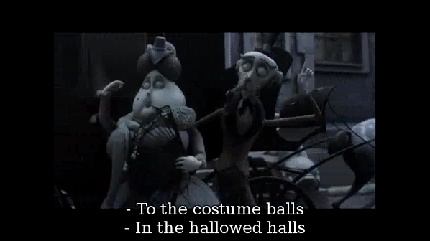

**“In the hallowed halls”**

Analysis:

**PP**

**/ \**

**P NP**

**/ / \**

**in Det N'**

**/ \**

**the Adj N**

**| |**

**hallowed halls**

In the film "*Corpse* *Bride*", the prepositional phrase "in the hallowed halls" functions as a modifier that provides a rich sense of place. A syntactic analysis discloses that the phrase consists of the preposition "in," which functions as the head of the phrase, followed by the prepositional object, which is the noun phrase "the hallowed halls." The determiner "the" in this noun phrase serves to specify and clarify the reference, while the N-bar (N') acts as an intermediate layer that allows for modification. The adjective "hallowed" functions as a modifier, endowing the noun "halls" with a sense of sanctity and reverence. Consequently, the phrase "in the hallowed halls" serves not only as a reference to a physical location, but also establishes an immersive and emotional atmosphere that reflects the thematic elements of life, death, and memory that are central to the film's narrative. The employment of this locative prepositional phrase serves to augment the audience's visual and emotional experience, thereby inviting them to contemplate the profound significance of the depicted locale.

**Datum 2**

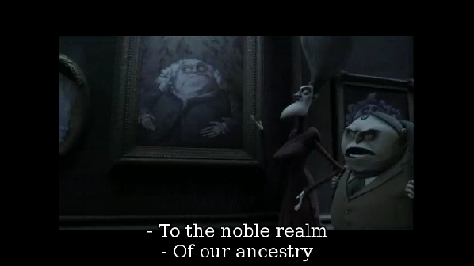

**“To the noble realm”**

Analysis:

**PP**

**/ \**

**P NP**

**/ / \**

**to Det N'**

**/ \**

**the Adj N**

**| |**

**noble realm**

The prepositional phrase "to the noble realm" functions as a complement, denoting movement or direction towards a particular objective.Fundamentally, this structure comprises the preposition "to," which imbues a sense of direction or purpose, in conjunction with the noun phrase "the noble realm," which serves as a complement. The noun phrase under scrutiny consists of multiple elements, beginning with the determiner "the," which introduces a sense of definiteness, followed by the adjective "noble," which qualifies the noun, and finally, the noun "realm," which functions as the primary reference.The N-bar (N') structure within this noun phrase enables modification, thereby allowing the adjective "noble" to enhance the meaning of "realm." Semantically, the preposition "to" establishes a vector of movement or direction that points toward what is described as "the noble realm," signaling either a literal or metaphorical endpoint for the action.Together, this combination of syntax and semantics underscores the phrase's function as a directional prepositional phrase, emphasizing movement or focus toward a defined and exalted goal.

**Datum 3**

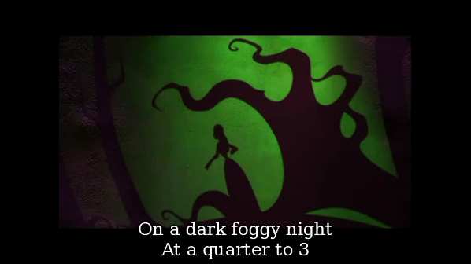

**“On a dark foggy night”**

Analysis:

**PP**

**/ \**

**P NP**

**/ / \**

**on Det N'**

**/ \**

**a Adj N**

**/ \ |**

**dark foggy night**

In the film "*Corpse* *Bride*," the phrase "on a dark foggy night" functions as a prepositional phrase with an adverbial role of time, providing a crucial time setting for the narrative and establishing the mood of the film. The structure of the phrase commences with the preposition "on," which functions as the core element, thereby establishing a clear connection to the temporal framework within which significant events unfold. The noun phrase "a dark foggy night" serves to define the specific time frame within which the events of the film take place. The noun phrase is initiated with the determiner "a," which introduces vagueness and allows for multiple interpretations. It also contains an N-bar (N') with two adjectives, "dark" and "foggy," that serve to reinforce the meaning and contribute to an eerie and suspenseful atmosphere. In this context, "night" functions as the head noun, providing a robust temporal focus. Semantically, the preposition "on" situates the events within the framework of the described night, not only denoting time, but also creating an environment that supports the film's themes of love, death, and mystery. Consequently, the phrase "on a dark foggy night" functions not solely as a time marker but also as a narrative element that serves to intensify the atmosphere and emotions of the story. The audience is thus invited to experience the tension and beauty of the night, thereby establishing a foundation for the extraordinary events that are about to unfold.

**D. CONCLUSIONS**

This research study investigates the syntactic structure and function of prepositional phrases in Tim Burton's animated film "*Corpse* *Bride*". Utilizing the syntactic analysis framework developed by Francis Katamba and Wunderlich, the study identifies and examines 16 distinct instances of prepositional phrases, each playing a unique role in the film's narrative and dialogue. Among the phrases to be analyzed are "In the hallowed halls," "To the noble realm," "On a dark foggy night," and "By the fire. " Through the use of syntactic tree diagrams, these phrases are deconstructed to reveal their hierarchical organization, illustrating how each component contributes to the overall structure and meaning of the dialogue.

The analysis highlighted the multifaceted contributions of prepositional phrases in enhancing the narrative. Firstly, these phrases provide essential spatial and temporal context, helping the audience understand the location, time, and circumstances surrounding actions and events. For example, expressions like "On a dark foggy night" effectively anchor the narrative in a distinct setting, deepening the viewer's engagement with the environment. Likewise, the phrase "by the fire" creates intimate spatial references that emphasize character interactions.

Secondly, prepositional phrases add depth to the complexity of character relationships and emotional exchanges. They play a crucial role in subtly communicating cues about the characters' emotional phrases, intentions, and their connections with both their environment and one another. For example, take the phrase "to the glorious realms. " This expression not only indicates a direction but also carries implications of purpose and grandeur, which may reflect the characters' aspirations or motivations.

Using tree diagrams as an analytical tool is highly effective for clarifying the syntactic relationships within phrases. This study carefully examines the role of prepositions as the main elements of their phrases and delves into how determiners, adjectives, and nouns contribute to the structural and semantic integrity of these phrases. This visual representation offers a clear insight into how these components interact to create coherent and meaningful expressions in dialogue.

**E. REFERENCES**

Altheide, D. L. (1987). Reflections: Ethnographic content analysis. *Qualitative sociology*, *10*(1), 65-77.

Katamba, F. (1993). *Modern Linguistics Morphology*. (1st edition).

Katamba, F. (Ed.). (2004). *Morphology: Morphology: its place in the wider context* (Vol. 6). Taylor & Francis.

Putri, Y. E., & Syarif, H. (2020, August). An analysis of prepositional phrase used in thesis at graduate program of Universitas Negeri Padang. In *Eighth International Conference on Languages and Arts (ICLA-2019)* (pp. 241-247). Atlantis Press.

Sandelowski, M. (2000). Whatever happened to qualitative description?. *Research in nursing & health*, *23*(4), 334-340.

Wunderlich, D. (1991). How do prepositional phrases fit into compositional syntax and semantics?.