**SITUATION TYPES STATIC IN PHINEAS AND FERB CARTOON**

by:

Kheisya Syifa Azzahra

Sekolah Tinggi Bahasa Asing (STBA) JIA Bekasi

[kheisyasam09@gmail.com](mailto:kheisyasam09@gmail.com)

Abstract

This research is aimed to help others to understand about situation types static through the Phineas and Ferb cartoon series. It is a cartoon which were release on 2007 about two stepbrothers named Phineas and Ferb who's turning their crazy brainstorms during summer vacation into reality. The reasons why the writer pick Phineas and Ferb cartoon series as the object of this research is because it is the writer’s favorite childhood cartoon that leaves a certain impression to her. The data were analyzed using Saeed's (2016) semantics theory regarding situation types static on Semantic Fourth Edition book. This is a qualitative research with a descriptive analysis. The research found twenty four data, there are eight situation type statics and individual-level predicates. All of the data that the writer found in this research are stative verbs. However, the writer can not find other situation types static from data.

Keywords: Saeed, semantics, situation types, static, stative verb, individual-level predicates, Phineas and Ferb cartoon

1. **INTRODUCTION**

Linguistics is something that will eventually be learned if you are studying a language. Kreidler (1998, p.3) stated that linguistics focused on identifying the meaningful elements of a specific language. Inside linguistics, there are a lot of aspects that you will learn, one of them is semantics. Semantic (Saeed 2016, p.3) is a study about meaning that is communicated through a language. It means that it is a scientific study of a language, where a meaning can be determined depending on the sentence, phrase, or word.

There are a lot of aspects inside of semantics, one of them is situation types. According to Smith (1997) cited on Rathmann (2003), Situation types concern the eventuality of the intrinsic temporal properties. It could be said that situation types in semantics, is a framework to classify and analyze the nature of events, actions, or states which are described by predicates. Based on Saeed (2016, p.113), To classify a sentence level in a language, speakers are allowed to construct different points of situations by using semantic distinctions, which are situation types, tense, and aspect. In situation types, there are two situations that could be described. They are static or states and dynamic. For this paper, the writer decided that she will use situation types static to solve the problem that she faced.

1. **Stative or Static Situation**

States is a situation to describe static or unchanging events, conditions, and perception. For example;

1. Robert loves pizza.
2. Mary knows the way to San Jose.

From the example above, it could be seen that the events that happen in a and b won’t change, because it is something unchanging or static.

1. **Stative Verbs**

Stative verbs are verbs that are used to describe states in a sentence. For example;

1. Ann **has** red hair.
2. Jennie **loves** singing.

Stative verbs could also be used in past tense, for example;

1. Mary loved to drink coffee.

Here in a, we didn’t know how the state ended, whether Mary’s taste has changed or is she still around. We only know that Mary's relationship to drinking coffee existed for a while. It could be concluded that stative verbs are not progressive.

1. **Stage-Level Predicates and Individual-Level Predicates**

Maienborn (2004), which cited Chierchia (1995) and Kratzer (1995), said that stage-level predicates (SLPs) are described as predicates that express temporary or accidental properties. while individual-level predicates (ILPs) express something which are permanent or inherent properties. For example;

1. Mei was **tired** of walking.
2. Josh is **American**.

From a, you could see that the word “tired” is something temporary and it could change as time goes by, depending on how Mei condition progresses. While in b, the word “American” is something concrete or permanent for Josh because he was born with it.

The writer decided to use situation types static for this paper because the object of this paper used lots of static situation aspects and it will also help the reader of this paper to realize that inside a kids cartoon, there are interesting uses of word and sentence that could be explained on a deeper level.

According to Fandom Wiki (2008), Phineas and Ferb is an American animated television series made by Disney and it first aired on August 17th, 2007. It is a show about two stepbrothers named Phineas and Ferb who's turning their crazy brainstorms during summer vacation into reality. Their sister, Candace, didn’t like what her brothers did because it could be dangerous and too extreme, tried to snitch on them to their mother. But somehow, the evidence of their activity would always disappear whenever their mother could witness it. Inside of this show, there is also a side-story about Phineas and Ferb's platypus pet, Perry, who's secretly a spy agent with a nickname Agent P. His goal is to stop whatever evil scheme that a weird scientist named Dr. Doofenshmirtz do to destroy the city they lived in. Situation types static is needed for this paper analysis because the intention of the writer is to help people understand more further about situation types static in an animated cartoon show.

Another research was used by the writer as a reference for this paper analysis, which is “Situation Types in American Sign Language” by Christian Rathman (2020). This paper is a research about the situation types inside American Sign Language (ASL) and how to identify each types. This paper used Vendler (1967) based on Smith (1997) semantic theory situation types, which consist of states, activities, semelfactives, achievements, and accomplishment.

1. **METHODOLOGY RESEARCH**
2. **Method of the Research**

Qualitative research method is used for this paper. According to Creswell (2012), (based on Puspahaty & Musta’innah, 2023) stated, the qualitative research method had a descriptive trait because it involved how the process, meaning, and understanding is collected on words or picture and not number. It could be concluded that the process of the research will consist of the process of data collecting, the data analysis which focuses on specific problems, and the result of the research based on the writer's interpretation.

1. **Time and Place of the Research**

This research started after the STBA JIA'S midterm test finished, which was on 18th of November 2024. Because this paper used a qualitative research method, there is no specific place to do the research since the writer could execute it anywhere. Mostly, the research paper was done at the writer's home and STBA JIA.

1. **Setting of the Research**

The setting of the research is a disney animation series show named Phineas and Ferb. The data was obtained through Youtube.

1. **Technique of the Data Collection**

Based on Gusti et al, (2021) there are seven ways of data collecting, but the writer will only focus on two, which are documentation and observation. It is because the writer decided to collect the qualitative data through the internet media, such as youtube, and then she will observe the data.

1. **Technique of the Data Analysis**

After the data has been collected, the writer will then analyze the data and underline the word that is classified for the static situation types and explain it on a deeper level using the knowledge and theory from Saeed (2016).

1. **Instrument of the Research**

Since this paper used a qualitative research method, the instrument for this research would be the writer herself. The writer will analyze data based on the theory and will give an acceptable reasoning.

1. **RESEARCH FINDINGS AND DISCUSSIONS**

The research findings of this paper will use documentation from the Phineas and Ferb series, where it will be using; episode one (Rollercoaster). The writer will choose specific scenes which contain situation types static dialogs, and then she will explain it on a deeper level based on the situation types static’s theory (Saeed, 2016). There will be six data that the writer would analyze for this paper. To find situation types static from the data, the writer classified the findings into four, which are the situation types, stative verbs, individual-level predicates, and stage-level predicates. The writer then found eight situation type statics, eight stative verbs, eight individual-level predicates and zero stage-level predicates from the 6 data.

**Figure 1.** Diagram of finding analysis research 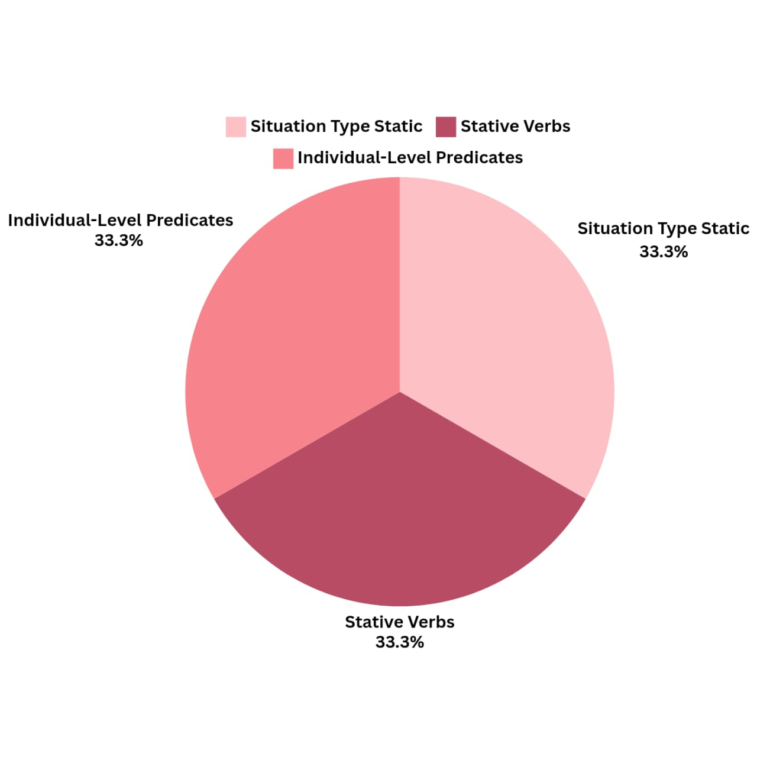

1. **Datum 1**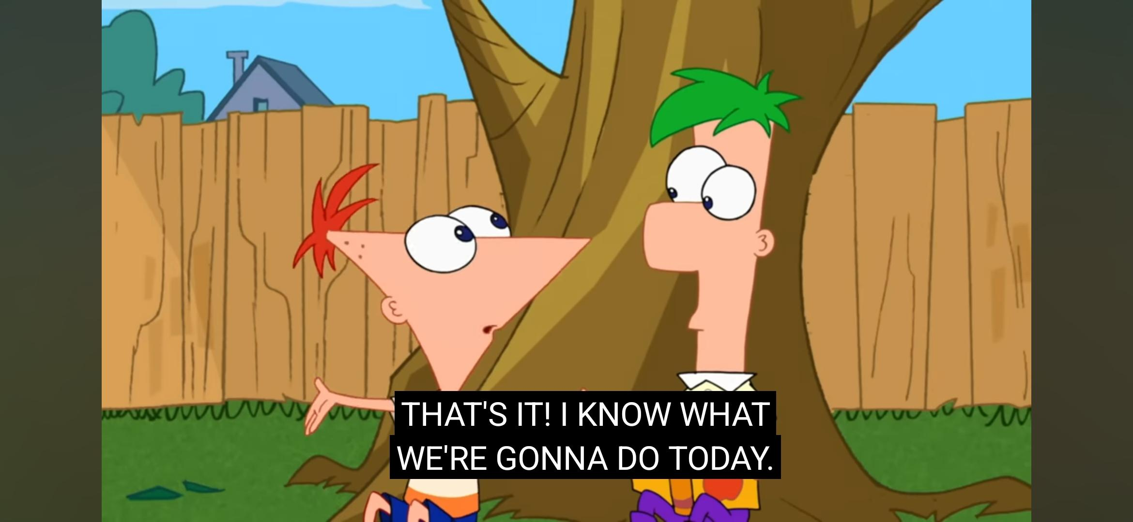

Dialog: “That’s it! I **know** what we’re gonna do today.” (1:36)

This sentence above had situation types static because it is a situation which talks about something that is inside the speaker's mind. The word “know” in the sentence is a **stative verb** and it is also an **individual-level predicate** because it is something that the speaker had or possessed, which is patent. The context of the sentence above is indicating individual-level predicates because “I know what we’re gonna do today.” is showing that the speaker's mind knows what they should do for today.

1. **Datum 2**

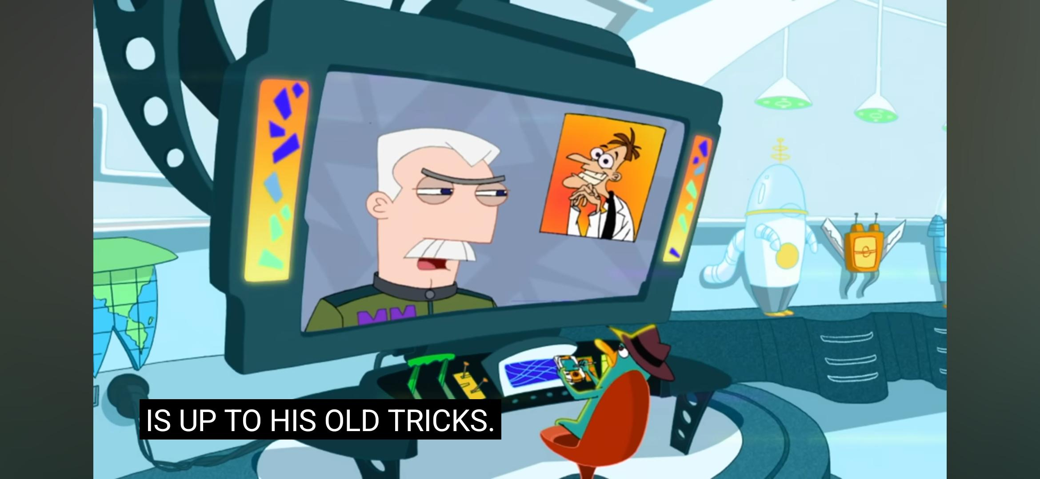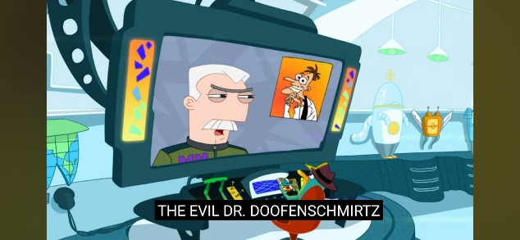

Dialog: “The Evil Dr. Doofenschmirtz **is** up to his old tricks.” (4:08)

The sentence above is indicating that it is a situation that hasn't changed from then until now, which is it is usual for the character to do something bad. Which means it is a static situation. “is” verb is a **stative verb** in the sentence because in the sentence, it is showing a state that is usual. The sentence also shows that it has **individual-level predicates** because the phrase “is up to his old tricks” is indicating to Dr. Doofenschmirtz, which means it is reflected to the character as something that he possessed.

1. **Datum 3**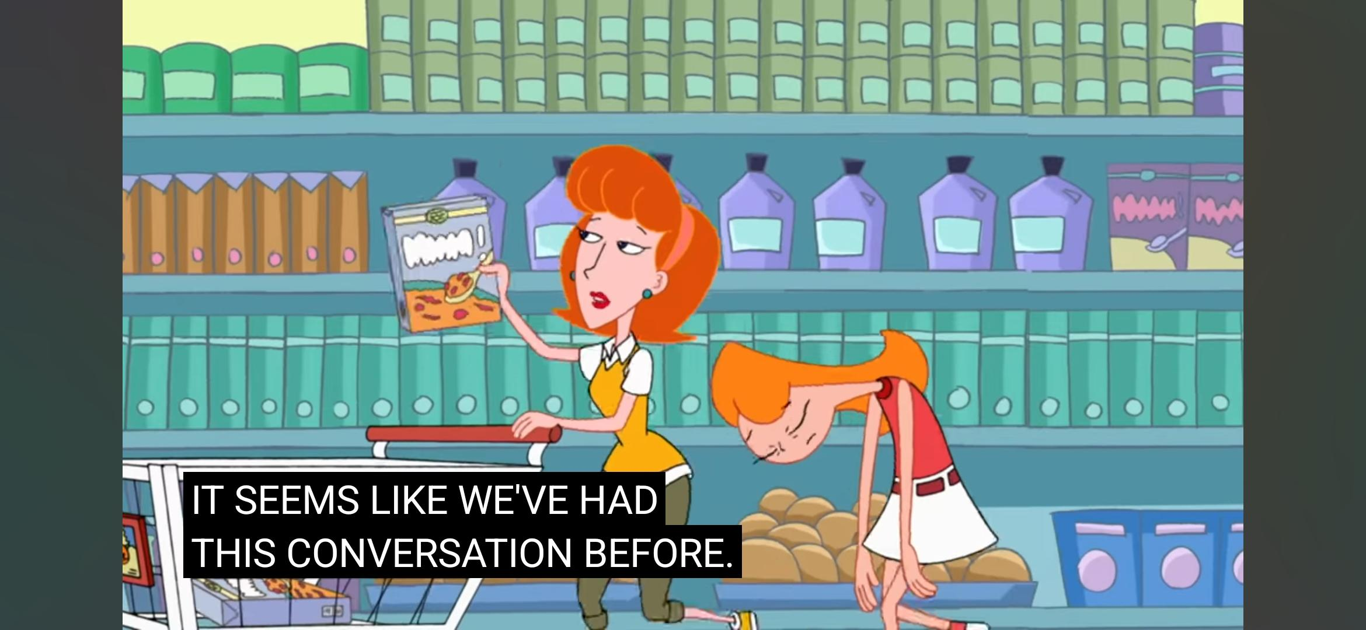

Dialog: “It **seems** like we’ve had this conversation before.” (4:53)

The sentence above is a stative sentence because it is explaining about feeling or having a perception about a past event that feels familiar now. The phrase “It seems like” is indicating a mental state of the speaker about their feelings regarding the situation because it use **stative verb** on the word “seems”, while “we've had this conversation before.” is describing a past event in a present situation. It is also an **individual-level predicate** because it indicates how the past had a relation to the present, and how the conversation now that they have is the same as the past.

1. **Datum 4**

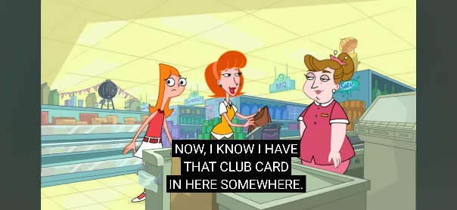

Dialog: “Now, I **know** I have that club card in here somewhere.” (9:30)

It is clear that the sentence above is a stative situation. It is because the sentence is describing the speaker's mental state of knowledge having the club card. The word “know” is a **stative verb** because it is stating about awareness of something. while the word “have” in “I know I have that club card in here somewhere” is also describing a mental state of knowledge or possession regarding the club card. Which could be said that it is an **individual-level predicate**. Because it describes a stable state of awareness.

1. **Datum 5**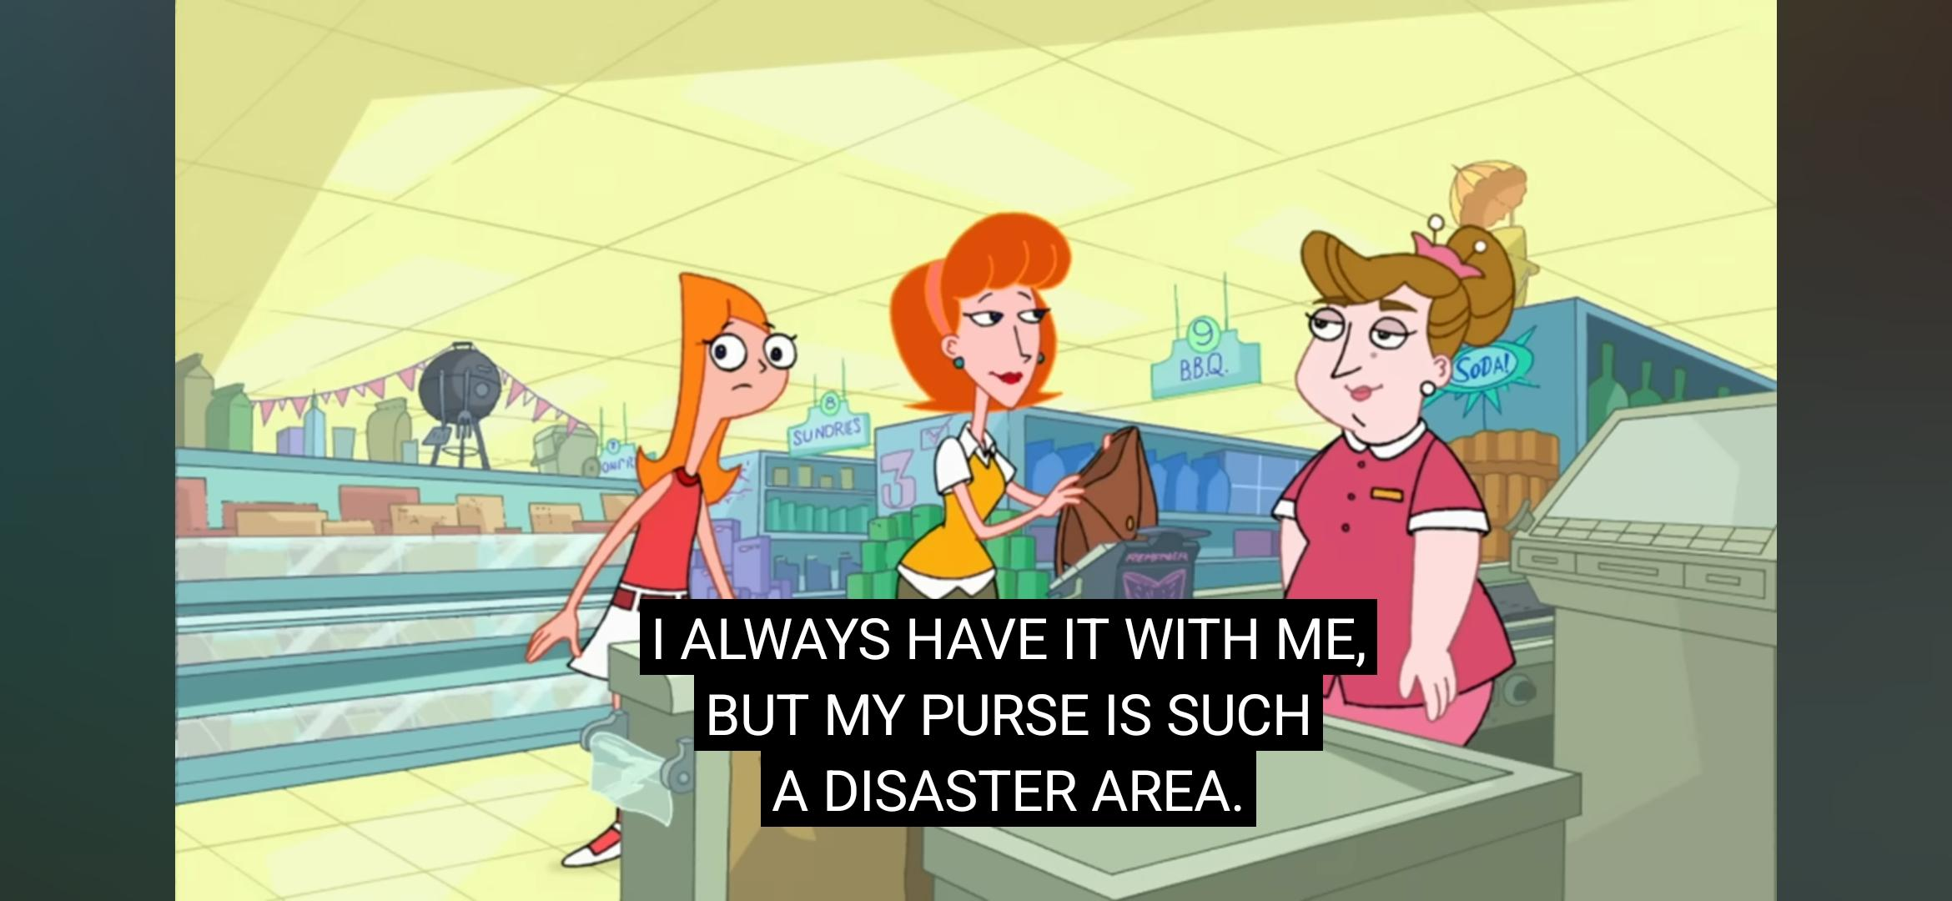

Dialog: “I always **have** it with me, but my purse **is** such a disaster area.” (9:32)

The sentence above consists of two stative situations. The first one is “I always have it with me” where it describes a possession state. The **stative verb** “have” is indicating a stable condition where the speaker had the items in question. It is also supported with the use of “always” adverb to show the consistency of the state. The second one, “my purse is such a disaster area” is also describing a stative state. The **stative verb** “is” indicates the current situation of the purse, which is to be described as disorganized.

Both of the sentences are also classified as **individual-level predicates**. It is because the phrase “ I always have it with me” is showing a stable state of possession, while “my purse is such a disaster area” is indicating a stable condition of the purse.

1. 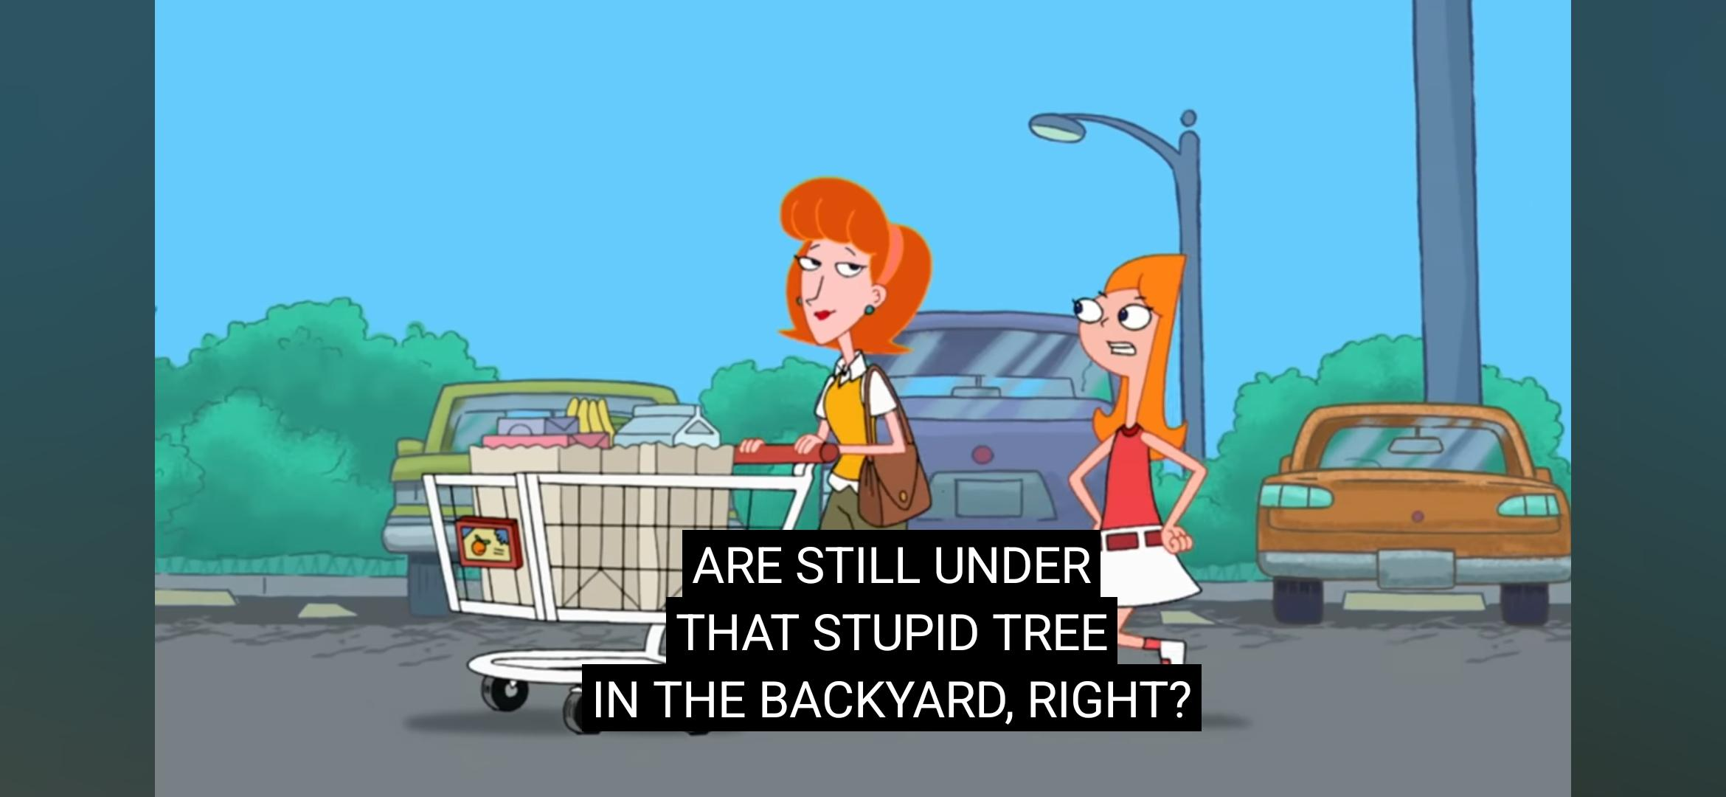**Datum 6**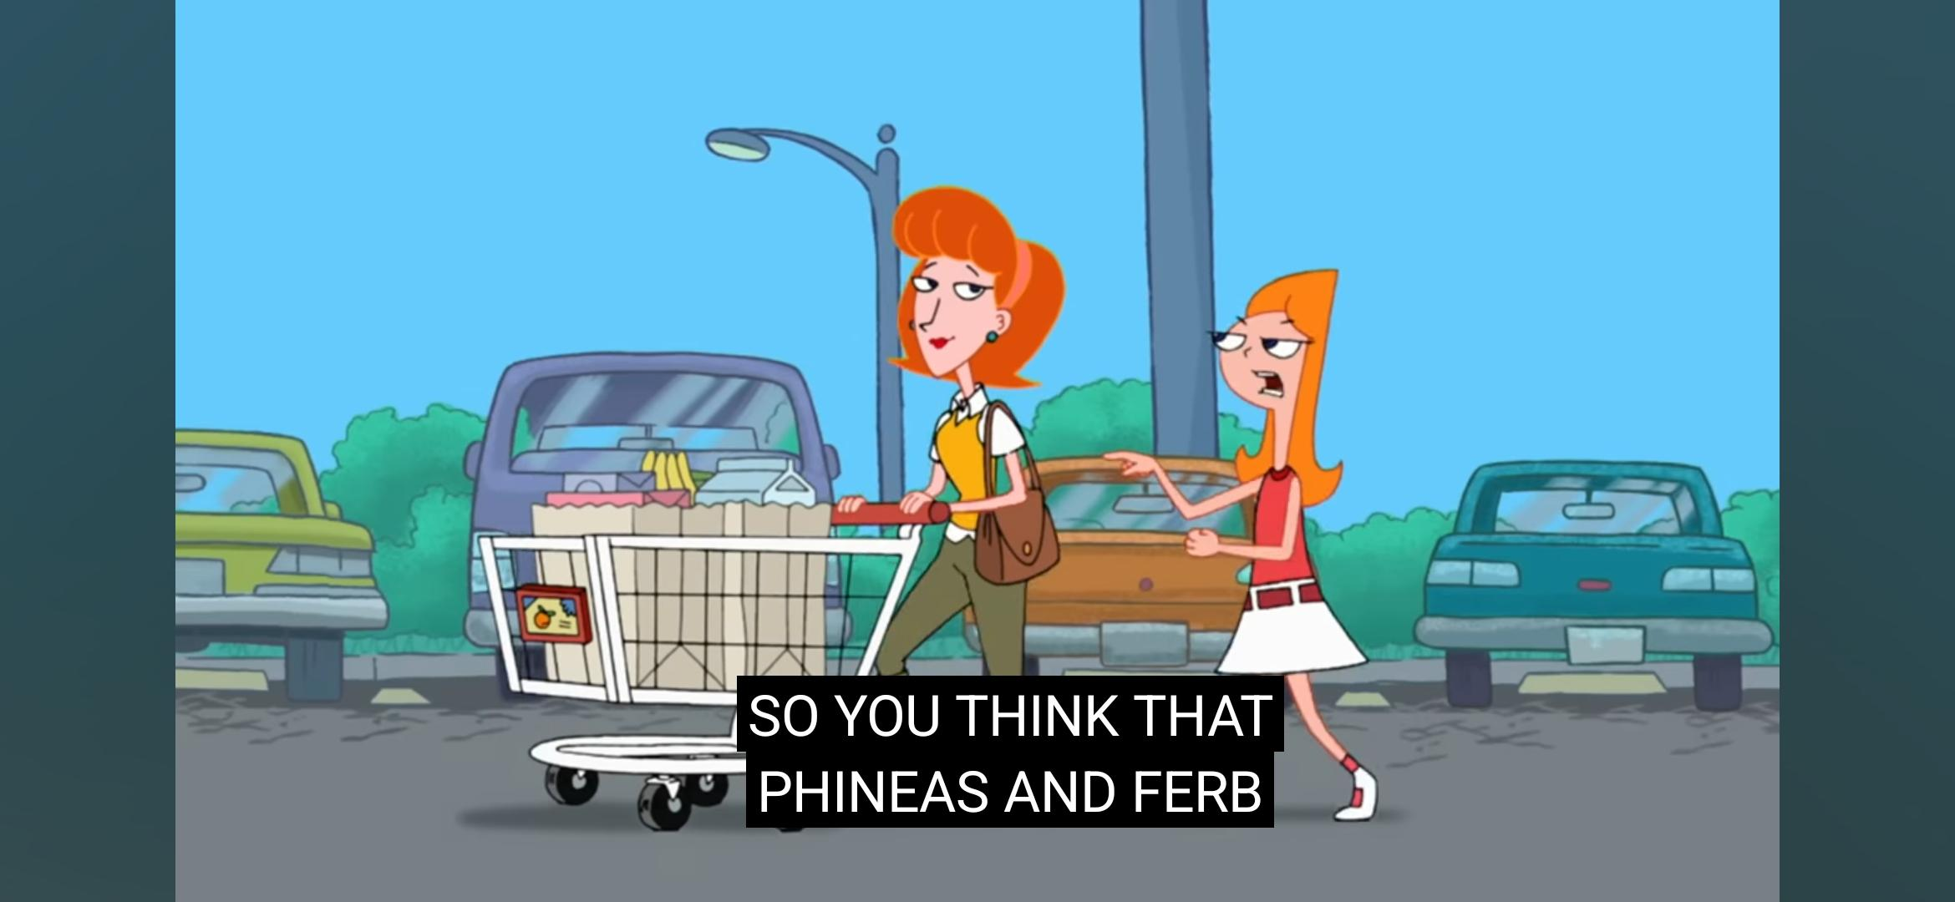

Dialog: “So, you **think** that Phineas and Ferb **are** still under that stupid tree in the backyard, right?” (10:21)

From the sentence above, the phrase “you think” is a stative situation where it indicates a mental state of belief about the situation due to the **stative verb** think. While the clause “Phineas and Ferb are still under that stupid tree in the backyard” specifically on the **stative verb** "are” is showing a stable situation of Phineas and Ferb's location. Both the phrase and the clause are individual-level predicates. It is because the phrase “you think” reflects on a mental state of belief and the clause “Phineas and Ferb are still under that stupid tree in the backyard” especially the use of “still” indicating a continuity of the stable situation of their location.

1. **CONCLUSION, IMPLICATION AND RECOMMENDATION**
2. **Conclusion**

After analyzing the 6 data from Phineas and Ferb cartoon series season 1 episode one (Rollercoaster) using Saeed (2016) theory on a deeper level, there are eight situation type statics, eight stative verbs, eight individual-level predicates and zero stage-level predicates.

1. **Implication**

The writer hopes that with the existence of this research paper, it could help the reader to understand more about what is situation type static, stative verbs and the individual-level and stage-level predicates.

1. **Recommendation**

In situation types, it is necessary to understand the three aspects of a sentence, which are events, actions, and states. So, it is important to learn it before we dive into situation types. Lack of understanding about events, actions, and states could lead to confusement in distinguishing the difference between situation types static and dynamic. To be able to understand more about these three aspects, it is recommended to read a lot of semantic books and exercise to analyze sentences to make it easier to comprehend the material and distinguish it.

**REFERENCES**

Kreidler, Charles W. (2002). *Introducing English Semantics*. Routledge.

Phineas and Ferb Wiki Fandom. (2008). *Phineas and Ferb.* Retrieved on December 11, 2024, from <https://phineasandferb.fandom.com/wiki/Phineas_and_Ferb>

Puspahaty, N., & Musta’innah, S. (2023). *Analisis deiksis pada lirik lagu dalam album “Sour” Olivia Rodrigo. Nautical : Jurnal Ilmiah Multidisiplin Indonesia, 1(11), 1414–1428.* <https://doi.org/10.55904/NAUTICAL.V1I11.641>

Rathmann, Christian. (2003). *"Situation types in American Sign Language," Semantics of UnderRepresented Languages in the Americas: Vol. 2 , Article 9.* <https://scholarworks.umass.edu/sula/vol2/iss1/9>

Saeed, John I. (2016). *Semantic Fourth Edition*. Blackwell.

Youtube (2022). *Phineas and Ferb First Episode | Rollercoaster | S1 E1 | Full Episode | @disneyxd.* Retrieved on December 13, 2024, from <https://www.youtube.com/watch?v=fLWBx37eKBM&list=PLg6R6yXKSLYB7kxBoElpG5rSgThsWdrzr>