PARTICIPANTS ROLES IN SOFIA THE FIRST: PRINCESS BUTTERFLY ANIMATION
Oleh:
Ghea Dwi Anzelia
Sekolah Tinggi Bahasa Asing JIA
ghebambam1a@gmail.com

Abstract
This research analyzes participant roles in the animation series titled Sofia the First, specifically in Season 1, Episode 19 titled "Princess Butterfly." Utilizing Saeed's (1998) theory. The writer uses descriptive qualitative research to examine the data. There are seven datums that were found in this research. The first and second data identified experiencer and theme, the third data revealed actor, agent, and beneficiary, the fourth data showed actor, agent, and theme, the fifth data identified experiencer, while the sixth data included agent and experiencer, and the seventh data revealed agent, experiencer, and theme. The analysis focuses on the episode “Princess Butterfly” because it offers rich dialogues with clear interactions between characters, which makes it suitable for studying participant and semantic roles in detail. The storyline also provides various actions and emotions, which help identify diverse linguistic patterns.
Key words: participant roles, Sofia the First, semantic, animation, roles

A. INTRODUCTION
When humans read something, they often only get the general meaning without truly seeing how the sentence is formed or the importance of each item in it. Every sentence has an interesting structure where the verb and other parts like the subject or object work together to convey a specific meaning. Unfortunately, these things are often skipped over because people tend to
focus only on the message they want to convey.

Based on Halliday (1978, p.1), language is the main tool used by humans to communicate and create meaning. Every sentence reflects the connections between actions, participants, and the situational context. As a complex form of communication, language not only has a part in conveying information, but also describes the relationship between various entities in an event. On the other hand, language is a system of communication used to convey thoughts, emotions, and information. It is made up of words and rules that help us connect with others.
To achieve a more profound understanding of how language functions and sentences are constructed to convey meaning, literature is a useful way that provides a valuable medium for analysis. Through stories, videos, dialogues, and narratives, literature gives us the opportunity to observe how words and structures come together to create meaning, making it an ideal tool for studying to see the connections between language elements and the context in which they appear.
In ‘Semantics’ book by J. Saeed (2009, p.1) explains that semantics is the study of meaning in language, highlighting the meaning of words, phrases, and sentences. Saeed mentions that semantics concerns how people understand and interpret the meaning contained in language and how it can change depending on the context. Semantics (Lyons (2001, p.145) is the branch of linguistics concerned with meaning. It involves the study of how language expresses meaning and how the structure of language relates to our understanding of the world. Several key areas of semantics contribute to our understanding of how language works and how meaning is constructed. These areas include lexical semantics, pragmatics, polysemy, ambiguity, and semantic roles. Each of these elements is important for understanding how language is applied to convey meaning and how speakers and listeners interpret it.
With the aim of understanding more deeply in the relationship between language and meaning, it is important to acknowledge the function of semantics in connecting actions, actors, and the context. Semantic roles can prove useful in understanding how each part of a sentence contributes to its meaning by demonstrating the particular role played by each participant in an event. These roles help explain not only the grammatical structure of sentences but also the deeper semantic connections that shape the narrative.
The study of semantics concentrates on the exanination of meaning in language, which is also considered a branch of linguistics (Hurford, 2007: p.1). Semantic roles (Gawron, 2013) help convey meaning in language that relate to the functions that participants in an event or situation fulfill in relation about the verb in a sentence. These roles include entities like the actor, the patient, the agent, the theme, and others. Kreidler (1998, p.56) stated that semantic roles are the functions that participants in an event perform in relation to the verb, for example the agent, theme, and recipient. Roles are identified based on common patterns, and labels provide an easy way to explain their purpose. Saeed (2009, p.148) introduces a list of semantic roles that consists of ten categories. These categories include actor, agent, experiencer, patient, beneficiary, instrument, theme, goal, source, and location.
- Actor
Is the main entity performing the action in a sentence.
Example: "Rina writes a poem.”
(In this sentence ‘Rina’ is an actor and the main performer of the action).
- Agent
Is the entity that causes the action, either directly or indirectly.
Example: "The wind blew the leaves." (In this sentence ‘wind’ is an agent as the cause of the action).
- Experiencer
Is the entity experiencing a feeling, emotion, or mental state.
Example: "Anisa feels happy.”
(In this sentence ‘Anisa’ is an experiencer because she is the one who’s experiencing the emotion).
- Patient
Is the entity that is affected by the action.
Example: "Farhan washes the clothes."
(In this sentence ‘clothes’ is a patient because the object is affected by the action).
- Beneficiary
Is the entity that has a benefit from the action.
Example: "He made tea for his mother.”
(In this sentence ‘mother’ is a beneficiary because she is the one who’s receiving the benefit).
- Instrument
Is the tool that is used to perform an action.
Example: "Ali cut the wood with an axe."
(In this sentence ‘axe’ is an instrument as the tool for the action).
- Theme
Is the entity that is the main focus of the action.
Example: "They are seeking the key."
(In this sentence ‘key’ is the theme or the main focus of the action).

- Goal
Is the destination or target of the action.
Example: "We are walking to the mountain."
(In this sentence ‘mountain’ is a goal or the destination of the action).
- Source
Is the origin or starting point of the action or entity.
Example: "She came from the school."
(In this sentence ‘school’ is a source or the starting point).
- Location
Is the place where the action happens.
Example: "They are playing in the park."
(In this sentence ‘park’ is a location or the place of the action).
By examining semantic roles, we can gain insights into how characters interact with their surroundings and with one another. This approach enables us to break down the linguistic elements within a story and understand their functions in conveying complex ideas. While semantic roles focus on basic functional semantics, there are other roles that focus on something more specific, namely participant roles.
Participant roles are known by several different names in linguistic studies, such as thematic relations or roles (e.g., Jackendoff 1990; Parsons 1995; Davis 2011), deep cases (Fillmore 1968), theta-roles (Chomsky, 1981), and semantic roles. Participant roles provide a more specific focus within semantic roles, referring to the ways characters or entities participate in the events of a story or dialogue. As Beatrice Primus (2014, p. 1-2) stated, participant roles help us understand not just what is happening, but who is involved and how the connections among the participants in the sentence are structured.
Media such as literature, films, and animations can be a playful approach to explore these concepts. In stories, the characters’ dialogues and actions not only advance the plot but also demonstrate how language is applied in meaningful and creative ways. By studying them more deeply, we can uncover the way sentences are constructed, how each part plays its role, and how everything comes together to create a rich and engaging narrative.
The choice of “Sofia the First: Princess Butterfly” as the research object relies on its popularity among children, the presence of many interesting characters and stories, and the rich narrative it offers. According to Disney Wiki (2020), Sofia the First is an animated television series that ran on November 18, 2012. Sofia is a young girl who becomes a princess after her mother marries King Roland II. Sofia tries to adjust toward her new existence as a princess, with the help of her stepbrother, James, and stepsister, Amber, as well as the headmasters at the Royal Preparatory School who are the trio of kind fairies from the Sleeping Beauty series. Sofia also possesses the powerful Avalor Amulet, which enables her to communicate with animals, shrink in size, and even transform becoming a mermaid. Nevertheless the evil wizard Cedric wants the amulet for his power to rule the kingdom of Enchancia. The show teaches values as an example, compassion, valor, be brave, selflessness, fidelity, being honest, and elegance, as well as focusing on genuineness and mercy. The colorful animation and engaging characters make it an enchanting choice for analysis. Participant roles are needed for this paper analysis through analyzing the actor, the agent, the experiencer, the beneficiary, and the theme in participant roles within this episode because of the intention of the writer to help people understand more further about participant roles in animation show, how each character plays a part in the events and how their interactions influence the story.
Another research was applied by the writer as a reference for this paper analysis, which is “Semantic Roles in Joko Widodo Re-elected as President of BBC Online News” by Maria Sidabutar & Zakrimal (2020). This paper is a research about the semantic roles including participant roles inside the news in Joko Widodo Re-elected as President and how to identify each type. This paper used Saeed (2009) theory for observing the different types of meanings in a sentence shows that the insights about the words in the sentence has been gathered.
B. RESEARCH METHOD
- Method of the Research
Within this investigation, the writer will use the qualitative research method to analyze the participant roles. Qualitative method (Denzin & Lincoln, 2000, p.8) is a research approach that focuses on collecting and analyzing non-numerical data, such as words, images, and social interactions, to comprehend the significance constructed by persons in a certain context. This research used a qualitative method, where the writer describes the data in detail. This method was chosen because it fits well with the research, as the data consists of text, image and words from the scene in the animation that were highlighted and included as participant roles.
- Time and Place of the Research
This research started after the STBA JIA’s mid term test finished during the writer's fifth semester, which was amidst of November 2024. The research was carried out primarily at the writer’s home and STBA JIA campus.
- Data Source of the Research
The object related to the research for this study is the popular Disney animation “Sofia the First” specifically in Season 1, Episode 19 with the title “Princess Butterfly”. The episode was chosen because it provides an excellent opportunity to analyze participant roles within the dialogue. The engaging characters and rich storyline allow for a detailed examination of how each character contributes to the events and interactions during the episode.
- Technique of Data Collection

The approaches that will be used for data collection in this research are documentation and observation. The documentation process involves several steps, including watching the relevant scenes and reviewing transcripts or subtitles connected to the research object. Since the concentration of the research centers on the sentences and conversations in the animation, documentation will assist in gathering suitable data for analysis. This approach will enable the writer to recognize and extract specific sentences from the animation for a thorough examination of participant roles.

- Technique of Data Analysis

After the data has been gathered, the analysis will begin by examining the participant roles from the dialogue and scenes. The roles of each character, such as actor, agent, experiencer, and beneficiary, and theme will be identified and categorized using the knowledge and theory from Saeed (2009).

- Instrument of the Research

The main instrument in this research is the “Sofia the First: Princess Butterfly” animation, particularly the dialogue and scenes from the episode. The writer will carefully analyze the interactions and activities of the characters to recognize their participant roles, such as actor, agent, experiencer, beneficiary, and theme. Using qualitative methods, the writer plays an important role in analyzing the data, providing appropriate scenes, and explaining the background of participant roles.
C. FINDINGS AND DISCUSSIONS
In this research, 5 data were found related to the participants roles of the animation Sofia the First : Princess Butterfly.
1.1 Datum 1
"I need your help, Cedric." (at the 5:09 minute mark)
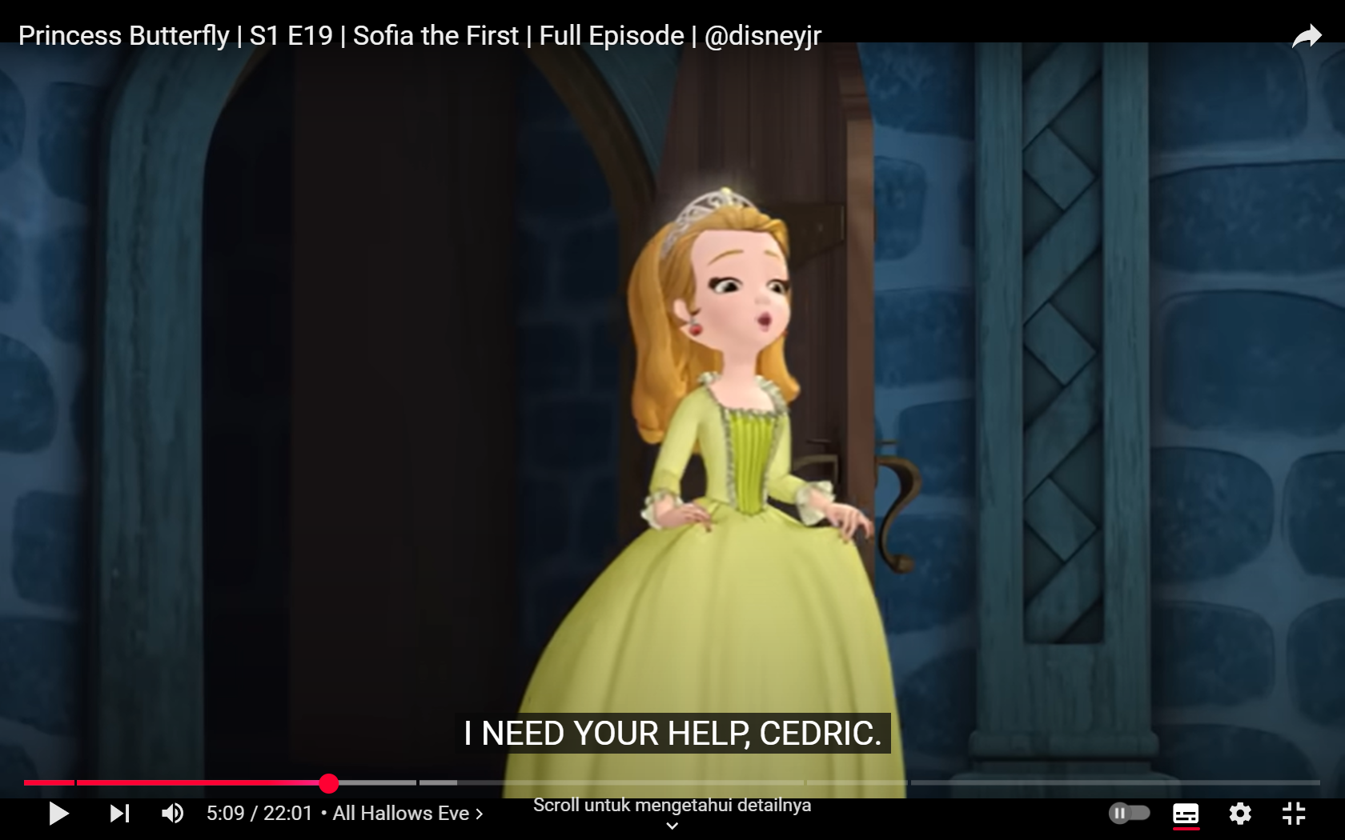
- Experiencer
Experiencer is an entity that experiences a feeling, emotion, or mental state. Usually, experiencers are related to verbs that show internal states, such as need, feel, think, or love. In this scene, Princess Amber is the experiencer because she says “I need your help” to Cedric. The word “need” here indicates a need or desire experienced from the speaker. In this situation, the individual experiencing the feeling of needing help from Cedric is Princess Amber.
- Theme
A theme is an entity or object that is the main focus of the action or need. Themes usually answer questions such as “What is needed?” or “What is the target of action?”. In the scene, “your help” is the answer to “What is needed?” and it becomes the theme because it is the central point of the need conveyed by Princess Amber to Cedric.
1.2 Datum 2
“All I need is a magic spell that will give me the most amazing butterfly costume in the whole world.” (at the 5:20 minute mark)
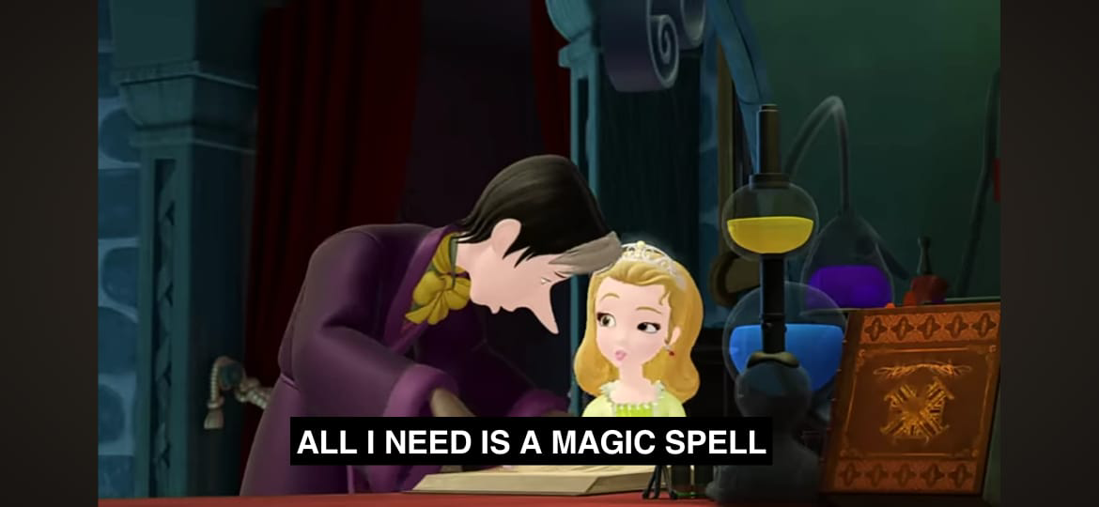
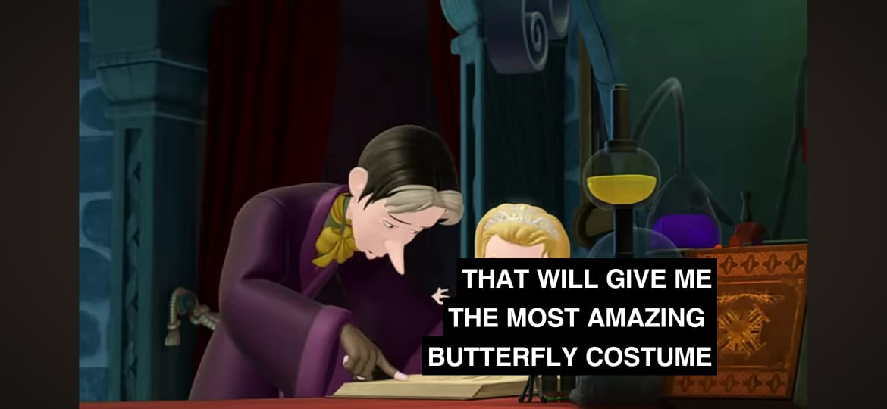
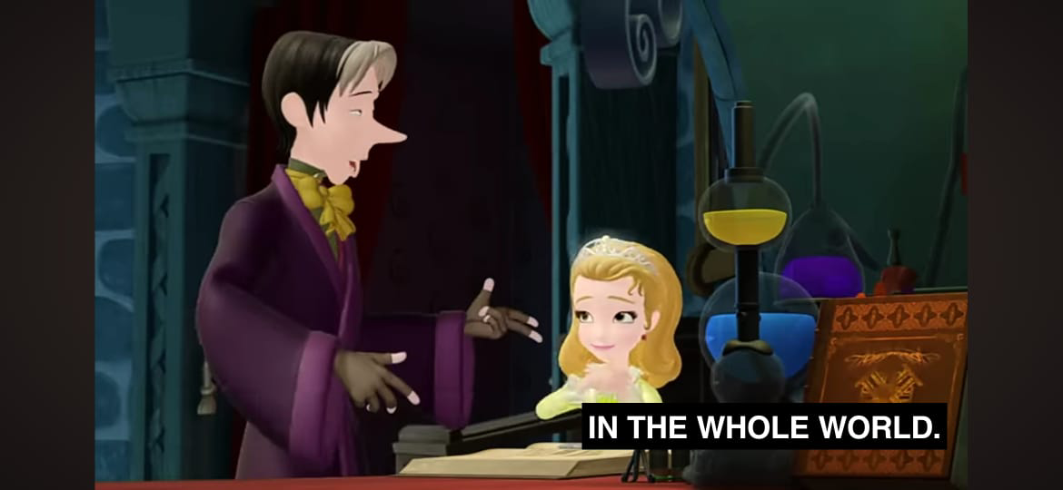
- Theme
“A magic spell” is the main theme in this scene because the magic spell that Cedric has is the object that is needed to achieve Princess Amber's goal of having the best butterfly costume for the Halloween party. This magic spell is the entity that the speaker needs to reach.
- Experiencer
The experiencer of this scene is Princess Amber because in this moment she feels that she needs “a magic spell” from Cedric that can help her to get a butterfly costume, because Princess Amber no longer knows how to get a costume that she will wear at the Halloween party later.
1.3 Datum 3
"On second thought, perhaps I can carve out a teensy bit of time for you after all." (at the 5:48 minute mark)
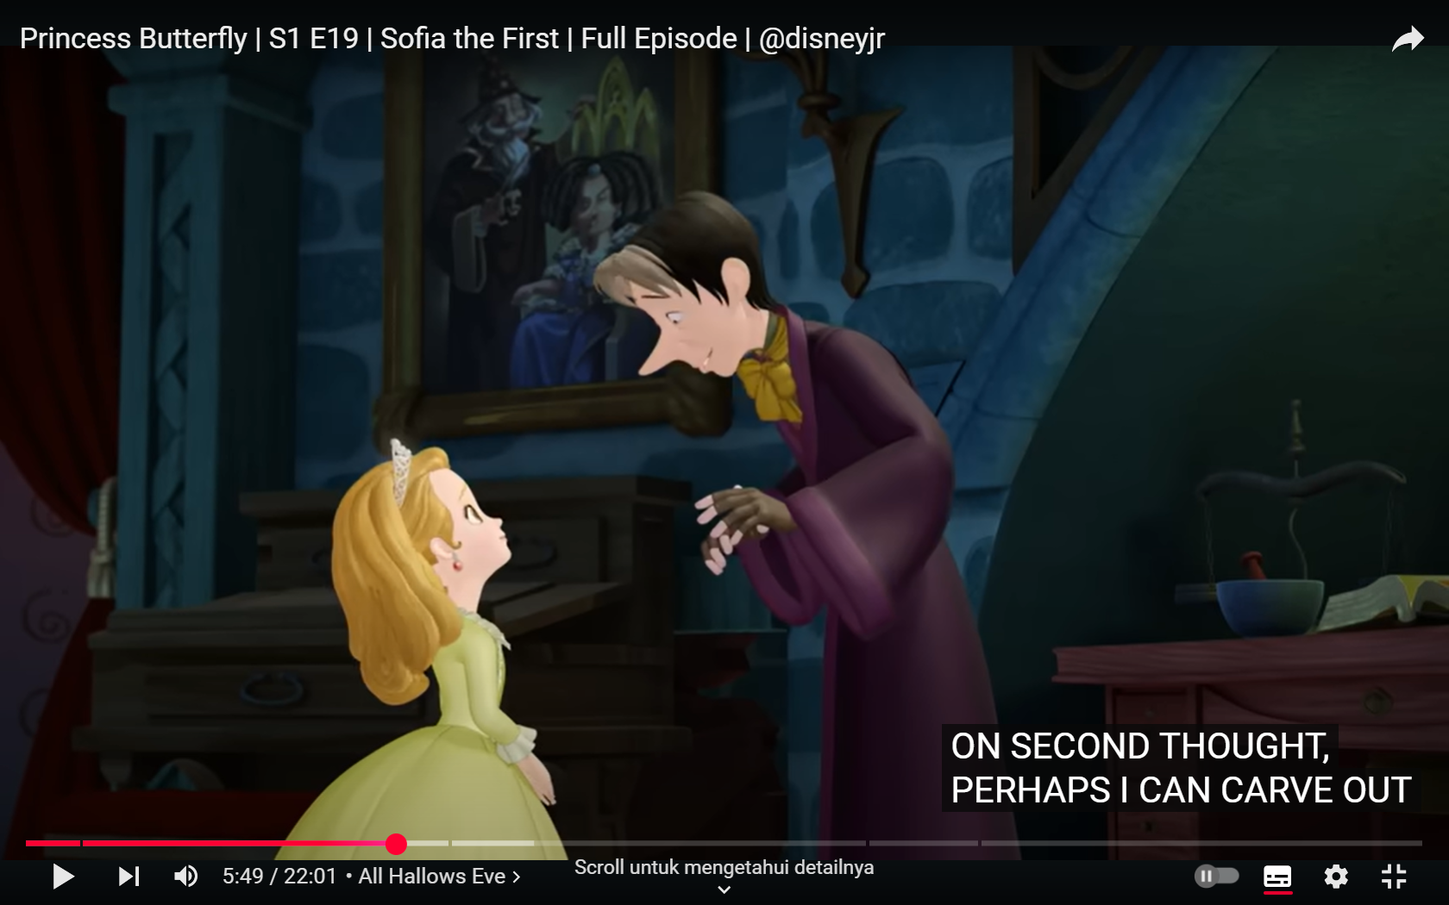
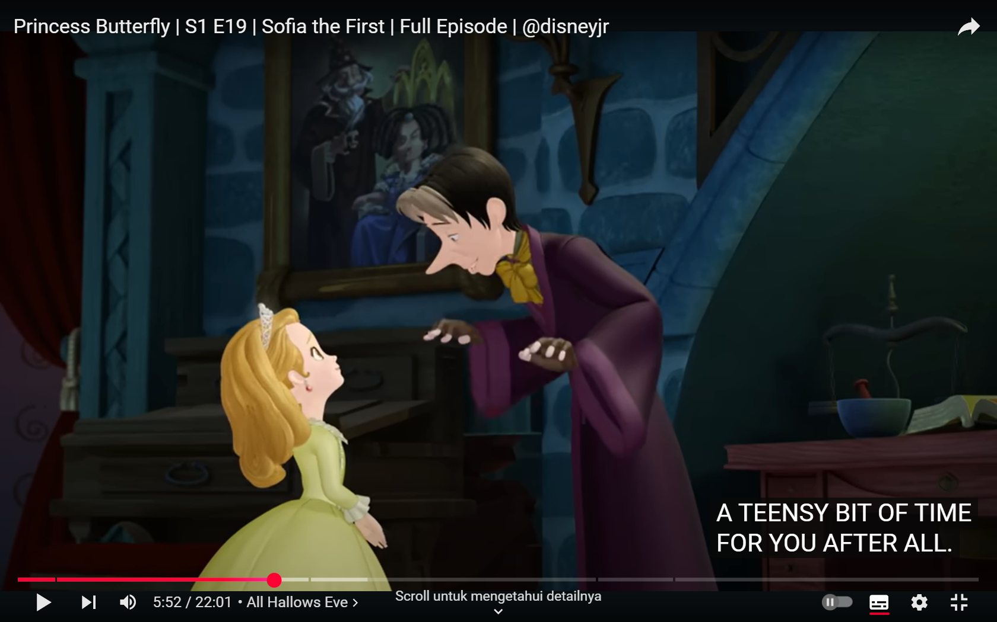
- Actor
Is the main entity performing the action in a sentence. In this scene it is Cedric who speaks and makes the choice to give some of his time to Princess Amber. “I” refers to Cedric who at first may not want to help Princess Amber's favor, but then finally Cedric chooses to spare some of his time for Princess Amber that needs some help.
- Agent
In this scene, the agent role is represented by the same entity, which is “I” or Cedric. This happens because “I” is the subject who consciously and deliberately carries out the action of “carve out” (allocating time), thus qualifying the criteria as an agent, which is an entity that causes an action, either directly or indirectly. In this sentence Cedric changes his mind to help Princess Amber who is having trouble making a Halloween costume, therefore Cedric acts as an agent because he made up his mind to accept Princess Amber's request for help.
- Beneficiary
In this scene, the person who receives the advantage or benefit of an action represents Princess Amber. In this case, “you” or Princess Amber is identified as the beneficiary because she will receive a brief time given by Cedric to help her with making or preparing the costumes for the Halloween event that will be coming up.
1.4 Datum 4
“I didn’t make my costume. I used one of Cedric’s magic spells.” (at the 16:38 minute mark)
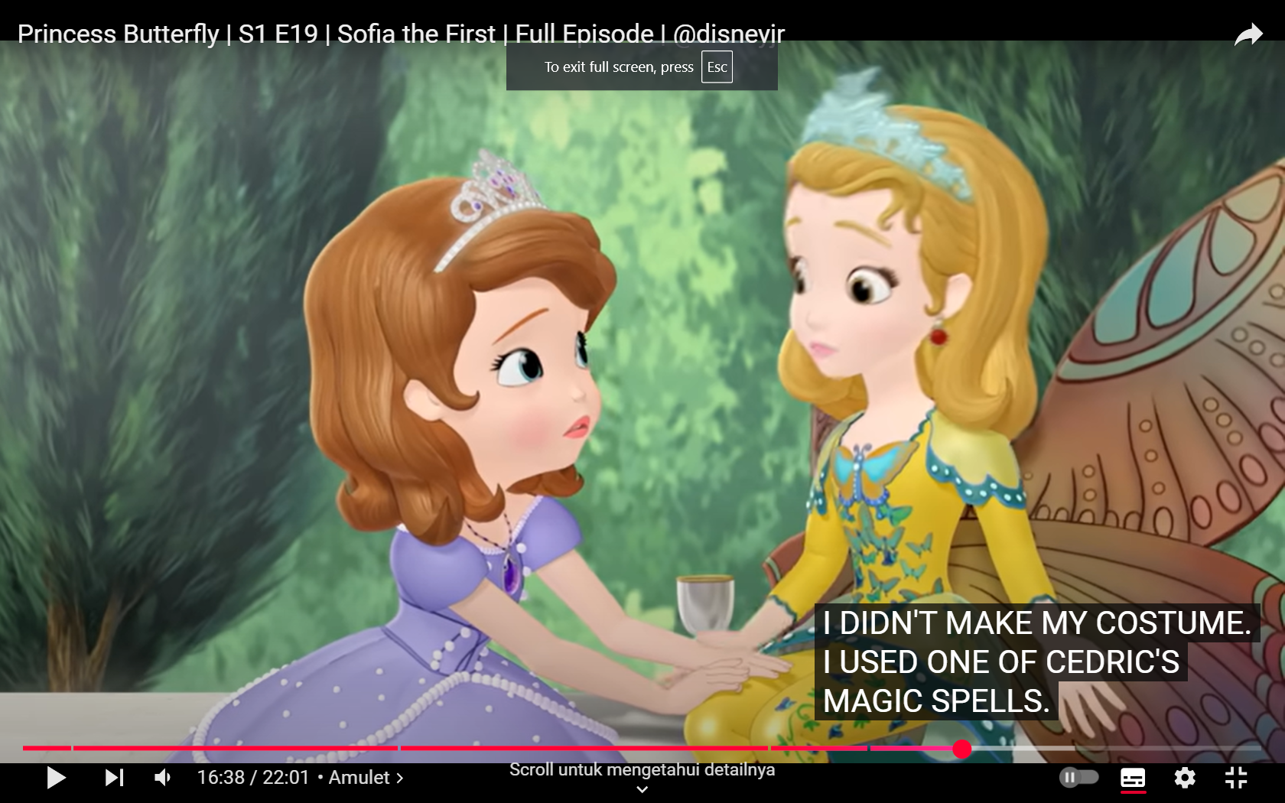
- Actor
In this scene, the actor is the main actor of the action, which is found in the sentence “I didn't make my costume”. The entity speaking here is Princess Amber. She did not make a costume for the Halloween event that will be held within the upcoming days.
- Agent
In the following scene, Princess Amber also acts as an agent because she is the entity that causes the action to happen. Princess Amber says “I didn't make my costume” but she used “Cedric's magic spells” as another way to get her costume.
- Theme
“One of Cedric's magic spells” becomes the theme in this scene because it functions as the main object used in the action "I used" by Princess Amber. “Magic spells” at this point is the main object used by Princess Amber to acquire the great costume that she will wear at the Halloween party.
1.5 Datum 5
“Did I just… fly?” (at the 10:43 minute mark)
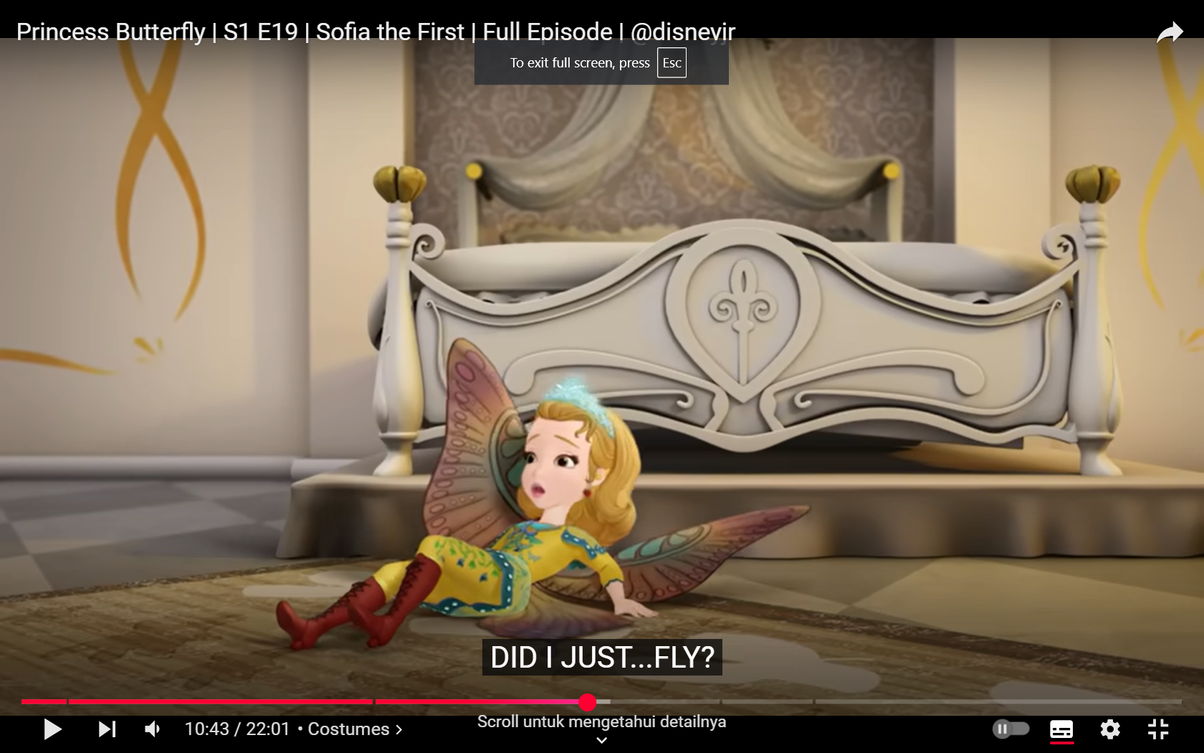
- Experiencer
This scene is considered an experiencer because in this scene it explains that this entity experienced an event, which is “fly”. The entity that experiences and feels this event is Princess Amber who is conveyed by the sentence “Did I just... fly?”. Princess Amber experiences confusion or uncertainty about what happened, which is whether she just flew or just her feelings. “I” feels the experience as a question about an unexpected event.
Based on the analysis that has been carried out thoroughly, it can be concluded that there are five types of triggers based on Saeed’s theory, namely actor, agent, beneficiary, experiencer, and theme.
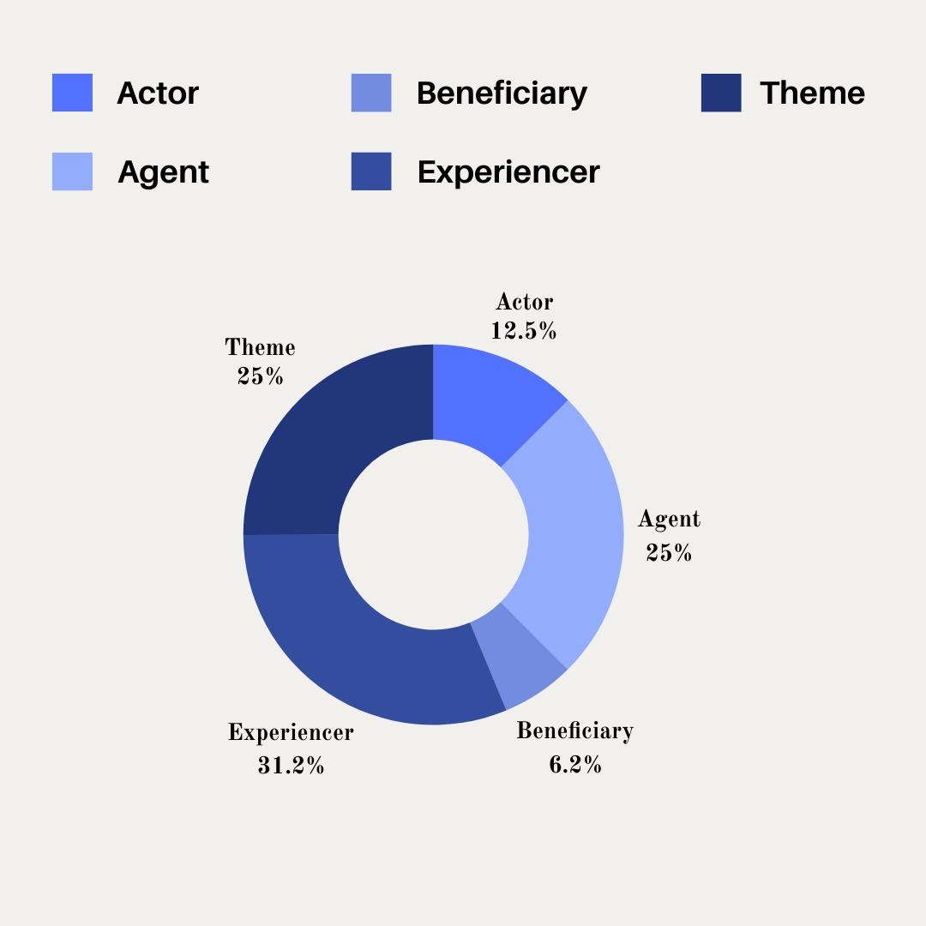
D. CONCLUSIONS, IMPLICATIONS, AND RECOMMENDATIONS
1. Conclusions
After analyzing Sofia the First: Princess Butterfly series in Princess Butterfly episode (E19, S1, 2018) using the theory of Saeed (2009) on a deeper level, the writer found seven datum of participant roles: actor, agent, experiencer, beneficiary, and theme. The analysis identifies and classifies a detailed comprehension of how these roles function and interact in the animation. This finding illustrates that each role is crucial in constructing the storyline and conveying the connections between characters, scene and events. Moreover, the characterization of these roles in dialog and scene reflects the animation's ability to engage the audience through its semantic complexity.
2. Implications
This research helps us understand how participant roles work in animated stories. It shows how these roles build meaning and enrich the story more interesting for the audience. It highlights the value of using animated series as a useful source of data. The writer hopes this paper could
assist the reader understand more about participant roles, types of participants roles and how these roles can be discovered in media like animation.
3. Recommendations
Analyzing participant roles in semantics requires careful attention to detail and a clear understanding of linguistic theory. Future researchers can consider how these roles appear in other types of stories or media to observe how they change in different settings. Studying the engagement between roles like actor, agent, beneficiary, experiencer, and theme can deepen our grasp of how meaning is constructed in language. This research highlights the importance of participant roles in creating coherence and engagement in the context of a story. By learning more about these roles, we can better understand how language connects actions, feelings, and ideas, which can help in teaching, storytelling, and further research.
REFERENCES
(Suhadi, 2011)Suhadi, J. (2011). Epistemic Modality and Deontic Modality: Two Sides of a Coin. Julisa, 11(2), 156–179.
Kreidler, C. (2002). Introducing English semantics. Routledge.
Saeed, J. (2015). Semantics and pragmatics. In The Routledge Handbook of Semantics (pp. 177-194). Routledge.
Gawron, J. M. (2013). Semantic roles and grammatical relations. USA: San Diego University.
Primus, B. (2015). Participant roles. In The Routledge handbook of semantics (pp. 403-418). Routledge.
Denzin, N. K., & Lincoln, Y. S. (Eds.). (2011). The Sage handbook of qualitative research. sage.
Lehmann, C. (2005, August). Participant roles, thematic roles and syntactic relations. In SKY Conference on.
Sidabutar, M. D., & Zakrimal, Z. (2020). Semantic Roles in Joko Widodo Re-Elected as President of BBC Online News. Linguistic, English Education and Art (LEEA) Journal, 4(1), 56-65.
Sofia the First Disney Wiki Fandom (2020). Sofia the First. Retrieved on January 06, 2025, from https://disney.fandom.com/wiki/Sofia_the_First

