**The Role of Person Deixis in Celebrity Interaction: A Video Analysis of Sabrina Carpenter on The Tonight Show with Jimmy**

by:

Maulida Kamila

Sekolah Tinggi Bahasa Asing JIA

Maulidakamila100603@gmail.com

Abstract

The objective of this study is to examine and identify the types of person deixis present in a YouTube video titled "Sabrina Carpenter Talks Short n' Sweet Album, Adele Singing "Espresso" and Jenna Ortega Cameo" on The Tonight Show Starring Jimmy Fallon's YouTube account. The selection of this particular song is attributed to the recent surge in popularity of Sabrina Carpenter. This research is an extension of Cruse (2000) theory on types of person deixis and reference to person deixis. The utterances are analysed qualitatively, emphasizing the importance of understanding person deixis in a conversation. Using Cruse's theory, this research found a total of nine person deixis data along with their references. In this study, the author describes seven categories of data. The seven data described in this study are all categorized as third-person.

.

Kata kunci: Sabrina carpenter, Cruse, Person deixis

**A. INTRODUCTION**

It is an established fact that human beings engage in a multitude of dialogues on a daily basis. The act of communication entails not only the transmission of verbal statements, but also the conveyance of underlying concepts, meanings, and information. It is important to note that each utterance contains more than just words; it also encompasses social relationships, contexts, situations, and the social roles of individuals involved in a conversation. It is imperative for us to understand that language is not merely a means of conveying a literal message; it is a medium that conveys far more than that. Language also carries a more complex and profound message.

In the field of linguistics, a course known as pragmatics is offered. The objective of this course is the examination of the meaning inherent in verbal exchanges. This concept is further elaborated by Cruse (2000, p.379), who defines pragmatics as the study of language that involves the interpretation of messages contained within an utterance in a given context without the explicit articulation of the message. Based on Saeed (2016, p.15), pragmatics is a branch of semiotics that focuses on the interpretation of signs and symbols, particularly in the context of communication. It involves the analysis of how meaning is derived from an utterance, taking into account the specific circumstances of its production and reception.

Yule (1996, p.3) in his book highlights that pragmatics is the study of the meaning in speech or writing when the speaker or writer is not intending to convey a particular meaning, and instead, the listeners or readers are expected to interpret the text based on their own experiences or preconceived notions. In essence, pragmatics is the study of how meanings are obtained from an utterance or written text.As Kreidler (1998, .p19) accurately points out, the fundamental purpose of the term "pragmatic" is to facilitate the process by which the listener derives meaning from the speaker's utterance regarding a particular subject. This concept encompasses the implicit information that the speaker has stated.

Pragmatics comprises several distinct elements, with one of these elements being deixis. Saeed (2016) posits that deixis is a linguistic phenomenon characterized by the act of pointing to something, emphasizing its relevance within the context of the conversation. Yule (1996) posits that deixis is a manner of pointing in a linguistic context that incorporates references to the entity being indicated, which can be personified as a person, an object, a place, or a time.

Kreidler (1998) posits that deixis pertains to a reference that is contingent upon a specific context, which is in turn influenced by the speaker's identity, location, and the temporal parameters of the utterance. Cruse's theoretical framework posits that a word or expression serves as a designation for an individual, location, or temporal period within a specific context (2000, p. 319).

Cruse (2000, p. 319) demonstrates in his book that deixis is divided into five distinct categories: person deixis, spatial deixis, temporal deixis, social deixis, and discourse deixis. This classification system provides an invaluable foundation for the study of deixis, offering a comprehensive approach to understanding the multifaceted nature of this linguistic phenomenon. In this study, the writer's primary focus is on the analysis of person deixis. Horn (2006) argues in Saputri (2016) elucidates that personal deixis describe the roles of participants engaged in a conversation. The first person is designated as the speaker. The second person is designated as the interlocutor, who is addressed by the speaker or listener. The third person is designated as a non-interactive entity, referred to by the aforementioned parties.

Yule (1996) provides an explanation about person deixis, a term defined as a category in linguistics that describes people in a communication, is a significant concept in the field. According to Saeed (2016), person deixis is defined as a distinctive system that utilizes pronouns to specify the role of an individual in a given communication, classifying them as either first person, second person (singular or plural), or third person (singular or plural). Cruse (2000, pp. 319-320) notes in his book that the role occupied by an individual in a particular conversation is described by what is referred to as “personal deixis”. cruse also classifies into three parts:

1. The first person: singular (I/me) – plural (we/us)
2. The second person: singular (you) – plural (you)
3. The third person: singular (he,him,she,her,it) – plural (they,them)

The objective of this research utilizes a YouTube video titled "Sabrina Carpenter Talks Short n' Sweet Album, Adele Singing "Espresso" and Jenna Ortega Cameo," which was uploaded to the The Tonight Show Starring Jimmy Fallon YouTube account on August 23rd, 2024. The writer's decision to focus on the video as the object of research is predicated on the contemporary rise in prominence of Sabrina Carpenter, a factor which the author hopes will generate heightened interest among readers in this research.

Another rationale for the inclusion of this video is that, given its nature as an interview, it is believed by the author that the interview video exhibits a greater degree of personal demeanor and provides a clearer illustration of the reference. A thorough analysis of the video will be conducted to ascertain the presence of any explicit references to the person in question, along with a determination of whether the individual in question has previously been mentioned. In the event of a positive identification, an assessment will be undertaken to ascertain the category to which the individual belongs.

**B. METHOD AND INTRUMENT**

1. **Method of research**

Data collection and the process. this paper itself uses a qualitative method in which the way to use it is to collect data and also analyze the data object by describing it. According to A.Oun and Bach (2014) qualitative methods have several stages, but the two important things of qualitative methods are data collection and also the process of analyzing the data. It was also posited that these two elements constitute the foundational principles of qualitative methods. Absent these elements, the concept of qualitative methods becomes invalid.

As stated by A.Oun and Bach (2014) above, the author feels that this qualitative method is very suitable for this research, because the qualitative method uses descriptions to analyze data. In the analysis of person deixis, it is imperative to delineate the context of reference and its type, thereby ensuring researchers have a qualitative research method at their disposal.. Conversely, as noted by Viswambharan and Priya (2016) in Mohajan (2018), this qualitative approach involves the evaluation of a theory or concept through the analysis of data or objects to ascertain their inherent meaning or interpretation. In addition, Zohrabi (2013) in Mohajan (2018) asserts that qualitative research constitutes a social interpretation of phenomena through the utilization of open-ended questionnaires, classroom observations, journals, historical texts, or visual or textual materials.

1. **Time and Place**

The writer started this paper by searching for data, finding references, making outlines, analyzing the data, and discussing with friends and lecturers. This research began on November 23rd, 2024. the place of research is uncertain because this research uses qualitative methods, but most of this research was conducted at STBAJIA and at the writer's home

1. **DATA**

The dataset under consideration is comprised of a YouTube video bearing the title "Sabrina Carpenter Talks Short n' Sweet Album, Adele Singing 'Espresso' and Jenna Ortega Cameo" on The Tonight Show Starring Jimmy Fallon's official YouTube channel. The primary objective of this analysis is to examine the person deixis present in the video and to subsequently analyze the references of these person deixis.

1. **Technique collecting**

In order to locate the pertinent data, the author is first required to watch the video, after which they proceed to compile a list of the person deiksis and the reference that appears in the video. The author then organizes these elements into groups according to each type in a spreadsheet.

1. **Tecnique analysing**

Following the collection of data, the author proceeded to conduct a thorough analysis of the data. The analysis focused on the types of person deixis and their references depending on the context using Cruse's (2000) theory.

1. **Instrument**

The writer herself is the research instrument, as the research employs qualitative methods

C. **RESEARCH FINDINGS AND DISCUSSUION**

**DATUM 1**



[0:02 - 0:06] **Jimmy Fallon**: I'm so happy for you. *The album* is out. We can say it.

*It*'s officially out right now.

As indicated by the data presented, the word "It" is spoken by Jimmy Fallon in the sentence ‘The album is out. We can say it.’. According to the theory proposed by Cruse (2000), "It" is classified as a personal deixis of the third person singular type, typically employed to substitute for objects. From a pragmatic perspective, the word "It" undoubtedly refers to an object. In the context of the given data, the word that functions as a reference to "It" is "The Album," which was previously articulated by Jimmy Fallon.

**DATUM 2**

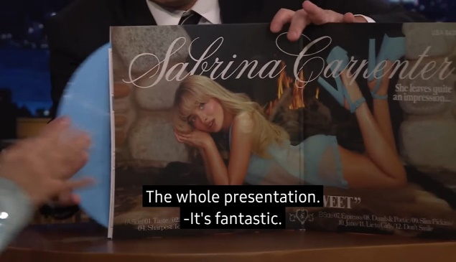

[0:09 - 0:18] **Jimmy Fallon**: Wow. *"Short n' Sweet*". I mean, come on, look at that,

with the colored vinyl, too. The whole presentation. *It's* fantastic.

As demonstrated in the previously mentioned data, the word "It" is spoken by Jimmy Fallon in the sentence ‘"Short n' Sweet". I mean, come on, look at that’. According to the theory proposed by Cruse (2000), "It" itself is a personal deixis of the third person singular variety, typically used to replace objects. From a pragmatic perspective, the word "it" undoubtedly refers to an object. In the context of the given data, the word that functions as a reference to the word "it" is an album entitled "Short n' Sweet," which was also enunciated by Jimmy Fallon previously.

**DATUM 3**

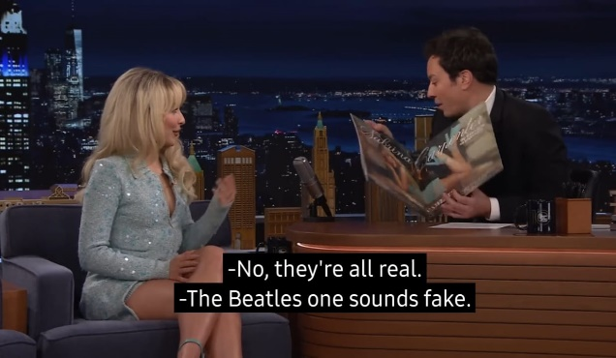

[0:33 – 1:03] **Jimmy Fallon:** *"Espresso" has been certified platinum and it was one of the fastest songs to reach a billion streams in the history of Spotify in the history. Number two, "Please Please Please" went to number one on the global Spotify chart dethroning you who already had the number-one spot with "Espresso”! And also, get ready for this. I don't know if you know this. I don't know this. You became the first artist since the Beatles to have two songs debut within the top three on the Billboard Hot 100.*

[1:10 - 1:13] –**Jimmy Fallon:** No, *they*'re all real.

As illustrated above, the data contains a personal deictic "They" uttered by the speaker, Jimmy Fallon in the sentence ‘No, They’re all real’. According to the theory of personal deixis proposed by Cruse (2000), the word "They" is classified as third-person plural personal deixis. Pragmatically speaking, the term "They" is clearly intended to refer to a specific entity. In this instance, the reference to "They" alludes to the accomplishments of the song "Espresso" and Sabrina Carpenter, which Jimmy Fallon has previously mentioned. This interpretation is supported by the following statement: Espresso" has been certified platinum and it was one of the fastest songs to reach a billion streams in the history of Spotify in the history. Number two, "Please Please Please" went to number one on the global Spotify chart dethroning you who already had the number-one spot with "Espresso”! And also, get ready for this. I don't know if you know this. I don't know this. You became the first artist since the Beatles to have two songs debut within the top three on the Billboard Hot 100”

**DATUM 4**

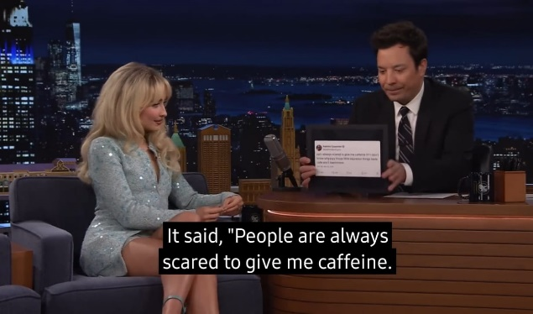

[2:43 - 2:48] **Jimmy Fallon:** *something that you tweeted*. *It* said, "People are always scared to give me caffeine. I don't know why. Those little espresso things taste cute and I like them”.

As demonstrated in the aforementioned illustration, the term "it" is articulated by Jimmy Fallon in the sentence "It said, 'People are always scared to give me caffeine. I don't know why. Those little espresso things taste cute and I like them’. The term "it" is a third-person singular personal deixis used to substitute for an object. From a pragmatic perspective, the term "it" is understood to refer to an object, as evidenced by the sentence "something that you tweeted." This suggests that the term "it" refers to a tweet that Sabrina Carpenter uploaded on the social media platform Twitter.

**DATUM 5**

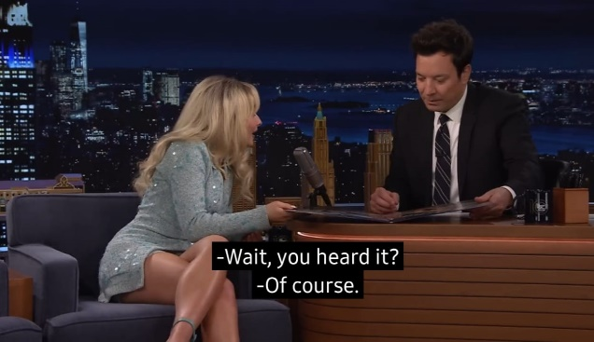

[3:39 - 3:41] **Jimmy Fallon:** I like *"Taste”*.

[3:41 - 3:42] **Sabrina Carpenter:**  Wait, you heard *it*?

As demonstrated in the previously cited data, the word "it" is articulated by Sabrina Carpenter in the statement "Wait, you heard it?" to her interlocutor, Jimmy Fallon. The word "It" is a personal deixis of the third person singular. From a pragmatic perspective, the use of "it" necessitates the presence of a referent. In this particular context, the term 'it' refers to a song titled 'Taste,' which was previously mentioned by Jimmy Fallon when he stated, "I like 'Taste’".

**DATUM 6**



[4:55 - 4:57] **Sabrina Carpenter:** *Jenna Ortega*, yeah!

[5:05 - 5:06] **Sabrina Carpenter:** and *she* was a huge fan of the film.

As indicated in the data presented above, the word "she" is articulated by the entity identified as Sabrina Carpenter. The word "she" is a personal deixis of the third person singular. From a pragmatic perspective, the use of 'she' can be understood as a reference to a female individual. In this particular context, the term 'she' is a reference to a female artist named Jenna Ortega. This reference was previously made by Sabrina Carpenter, who stated, "Jenna Ortega, yeah."

**DATUM 7**



[6:04 - 6:12] **Jimmy Fallon:** We're celebrating, and *she*'s performing for us later in the show. More "Tonight Show" after the break! Stick around everybody! *Sabrina Carpenter*!

As illustrated by the data above, the word "she" is present in the statement "she's performing for us later in the show," articulated by Jimmy Fallon. The word "she" functions as a personal deixis of the third person singular. From a pragmatic perspective, the personal deixis "she" unambiguously refers to a female individual. In this particular context, the term 'she' is understood to refer to a woman named Sabrina Carpenter. This reference was reiterated by Jimmy Fallon when he stated, "More 'Tonight Show' after the break! "Stick around, everybody!" Sabrina Carpenter!"

The following table presents a comprehensive list of the identified person dexes and their respective references as depicted in the video.

|  |  |  |  |
| --- | --- | --- | --- |
| **NO** | **DATA** | **AMOUNT OF DATA** | **PERCENTAGE OF DATA** |
| 1. | The First person | 0 | 0.0% |
| 2. | The Second person | 7 | 22.2% |
| 3. | The Third person | 2 | 77.8% |

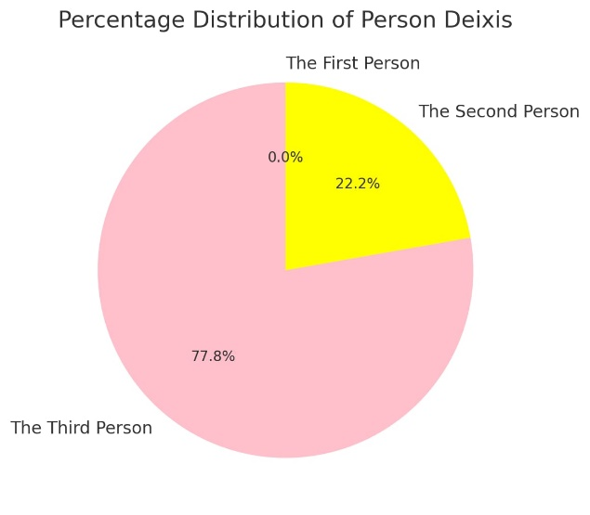

D. **CONCLUSION**

A recent study conducted by the author examined the person deixis present in a YouTube video titled "Sabrina Carpenter Talks Short n' Sweet Album, Adele Singing 'Espresso' and Jenna Ortega Cameo," which was uploaded to The Tonight Show Starring Jimmy Fallon YouTube account on August 23rd, 2024. The study identified seven third-person personal deixis, two second-person deixis, and zero first-person deixis.

**REFERENCES**

Saputri, K. (2016). An analysis of deixis in Black Swan movie script. *Global Expert: Jurnal Bahasa dan Sastra*, *5*(1).

Kreidler, C. W. (1998). Introduction to English semantics. Routledge

Yule, G. (1996). Pragmatics. Oxford University Press.

Cruse, D. A. (2000). Meaning in language: An introduction to semantics and pragmatics. Oxford University Press.

Saeed, J. I. (2016). Semantics (4th ed.). Blackwell Publishers.

Oun, M. A., & Bach, C. (2014). Qualitative research method summary. *Qualitative Research*, *1*(5), 252-258.

Mohajan, H. K. (2018). Qualitative research methodology in social sciences and related subjects. *Journal of economic development, environment and people*, *7*(1), 23-48.