**UNCOVERING DEONTIC MODALITY IN MOANA FILM’S SCRIPT**

By:

Sekar Arum Yolanda

STBA JIA

[sekararumyolanda@gmail.com](mailto:sekararumyolanda@gmail.com)

Abstract

This research aims is to find out and reflect on instances that show deontic expressions which are language constructions that express obligation, permission and prohibition in the film Moana. The writer chose the film Moana released on November 25, 2016 by directors John Musker and Ron Clements to analyze because of the enormous cultural influence of this film and its illustration of a protagonist who does not give up easily, has a sense of responsibility and defies traditional limitations. The writer uses Palmer’s concept of deontic modality in his book Mood and Modality. In this research the writer uses qualitative descriptive method. The writer has found thirteen data for this research. Obligation refer to datum 1 and datum 3, prohibition refer to datum 2, datum 4. This research does not find relevant data in the category of permission deontic modality.

Key words: *Deontic Modality, Moana, Linguistic Analysis*

**A. INTRODUCTION**

Modality is a modal expressions are those which signal a particular attitude on the part of the speaker to the proposition expressed or the situation described (typically in a statement) research by Cruse (2004, p. 286). Based on Saeed (2016, p. 134) devices that enable speakers to convey differing levels of dedication to or believe in a proposition are collectively referred to as modalities.

Kreidler (2013, p. 239) develops on to say that while people discuss facts like what is true and what is not, what has happened and what has not, we also discuss things that might or might not be true, what should or shouldn't be, what certain people can and cannot do, and what we have to do or not do. Together, these ideas make up modality.

Deontic modality concerns with saying “*must”*, “*may”*, or “*can”*. Lyons (1977, p. 823) classifies it as a deontic mode whereby emphasis is put on social and interpersonal obligations as opposed to knowledge of the speaker in deontic modality. This point is further expanded by Rescher (1970), who links deontic expressions to normative frames thereby emphasizing their significance in shaping the dynamics of societies.

According to Palmer (1986, p. 10), deontic modality enables us to understand discourse authority and power. In film scripts, Deontic expressions have dual roles; they reveal character relationships and move plotlines forward. In the opinion of Halliday (1985, p. 287), the deontic modality calibrates the meaning focus between Do it! And don't do it! While the epistemic modality allows the meaning emphasis between Yes and No.

Research by Van der Auwera (2012) shows that dialogues containing directive or responsibility negotiating moves are characterized by a high degree of prevalence of deontic modality. Lastly, Zhang (2019, p. 879) adds that modalities can help make clear character motivations in a movie script which becomes useful for doing more narrative analysis.

Cultural imperatives and individual choices are conveyed through deontic modality within the Moana context. Studies such as those showing how linguistic elements like these functionally contribute to narrative coherence have been done before such as Zhang’s (2019) study on the role of mood in film scripts. The current research incorporates this perspective into a wider debate on the place of language in storytelling that surrounds Moana.

Necessity, obligation, permission, and prohibition are terms employed in deontic modality which is a subfield of linguistic modality. This facet highlights the power relations, character motivations and thematic structures that underlie cinematic narratives. This is evident through the Disney animated film Moana, which portrays cultural values, leadership and personal growth as central themes in its application of deontic modality. As will be revealed in this research study on Moana’s script, deontic modality plays a significant role in character development as well as storytelling.

In building up narrative structures, especially those that blend cultural authenticity with universal themes in movies, this study focuses on the subtle role of deontic modality. Linguistic modality is a good example of how language is a narrative tool as well as an encoder of social and interpersonal values. This research utilizes Palmer’s (1986) theoretical framework to indicate how deontic expressions go beyond mere functions in plot development to directly affect the representation of themes. Therefore, it is argued for the inclusion of linguistic theories in media studies to improve understanding on how language influences storytelling.

The aim of the study is to find out and reflect on instances that show deontic expressions which are language constructions that express necessity, obligation, permission or prohibition. The decision to select the dialogues of Moana as a sample was due to its rich linguistic features, complex narrative structure and explicit engagement with themes such as culture identity, duty and leadership. Therefore, it makes sense to use it for considering how social roles and responsibilities are reflected through language.

The Writer selecting Moana for analysis as a subject owes much to the film’s immense cultural influence and its illustration of a tenacious protagonist who defies traditional limitations. The movie revolves around Moana, a young leader, who has to balance her desire to succeed with her duties towards her community thus creating an examination of deontic speech in leadership and sociology. Additionally, the narrative weaves together several universal themes like self-discovery and culture that make it an interesting example of how linguistic choices can express or build up the moral and cultural fabric of the story.

In perspective of the preceding reasoning, the following research topics are addressed in this study: 1. How did the author discover deontic modality in Moana? 2. How does deontic modality relate to character dynamics, permission, obligation, necessity, and prohibition?

**B. RESEARCH OF METHOD**

1. **Method of Research**

For conducting this analysis, a qualitative methodology is employed to explore the use of deontic modality in the script of Moana, an animated film. The analysis focuses on identifying key scenes where major thematic concerns dominate with a concentration of deontic expressions.

In order to obtain data, all dialogues that involved “must,” “have to” “need to” or “cannot” among others were isolated from each scene one at a time. These expressions were sorted out using Palmer’s (1986, p. 9) framework which classifies deontic modality into three main types; obligation, permission and prohibition.

Additionally, the research further explores how these utterances relate to their characters’ motivation purposes relationships action and how they contribute towards developing the broader story line or message within the film.

This study aims to show how deontic modality is used in Moana to express issues of duty, liberty and resistance. This work explores the language used in the film from a social and cultural perspective for it to be understood as a tool that can be employed for purposes of complicated exchange and management.

1. **Time and Place of The Research**

The analysis completed in 2025, mostly in December and January. A qualitative method could be used to process this research anyplace. The writer conducted this study at home.

1. **Setting of The Research**

The 2016 Disney filmed illustration Moana serves as the research's setting. Loklok was a tool to obtain the data.

1. **Technique of Data Collection**

The writer obtains data using the Moana film script by first examining the film's documentation though the internet media, and then the writer will watching the film and selecting the script for research, and lastly conducting an analysis of the data.

1. **Technique of Data Analysis**

After the writer has been collected the data, then the writer selecting the data for research and analyse the data. The writer must explain each of the data.

1. **Instrument of The Research**

The instrument of this research is the writer who analyzes the script of the film Moana (2016). The writer has determined each method of analysis related to this data based on the writer's ability and knowledge.

C. **RESEARCH FINDINGS AND DISCUSSION**

* + **Datum 1: Have to**

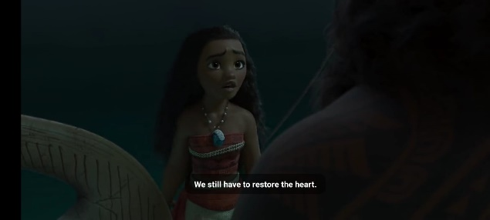

Dialog: “We still have to restore the heart.”

Moana's journey is deeply rooted in expressions of necessity and obligation, depicting her growth and her duty to her people. A pivotal moment occurs when Moana affirms to Maui at minute 01:16:45, “We still have to restore the heart” signifying their recognition of an obligation greater than themselves. The word “have to” here is an obligation that shows a sense of responsibility from themselves. If the sentence is changed to “We may restore the heart whenever we are ready” it will become a permission sentence because of the word “may”, or changed to “We must not ignore the need to restore the heart” it will become a prohibition sentence because of the word “must not”.

The context of the sentences of the film is Moana who initially hesitated to cross the ocean turned into a strong determination to save her village. And Moana must convince Maui to continue the journey and take responsibility for his actions.

Because Maui has broken *Te Fiti's* heart and made Moana's village will be destroyed, he himself must be responsible for restoring it. Maui initially refused for fear of further destruction, but when he saw Moana's strong determination, he changed his mind that he had to keep going to restore the situation from what he had done. Here too Moana has succeeded in her responsibility as chief to convince Maui and restore her village.

So the sentence falls into the obligation deontic modality category.

* + **Datum 2: Can’t**

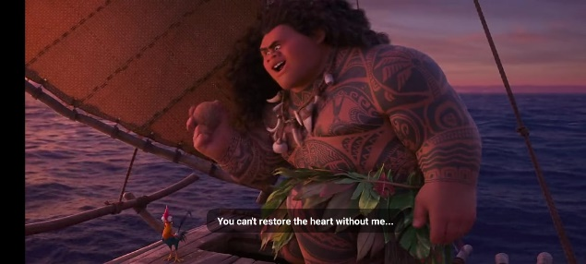

Dialog: “You can’t restore the heart without me.”

Maui's words “You can’t restore the heart without me” at 49:45 minutes emphasize that it is impossible to return *Te Fiti’s* heart without Maui's help. The word “can't” here indicates a prohibition or not given permission to Moana who wants to continue her journey alone. The word also shows necessity because Maui's presence is needed to help Moana in returning *Te Fiti’s* heart. In addition, the ocean is a sanction that allows and gives direction to Moana's journey. If the sentence is changed to “You can restore the heart with my help” it will become a permission sentence because of the word “can”, or changed to “You must involve me in the process of restoring the heart” it will become an obligation sentence because of the word “must”.

From the context of the film, before Moana became the new chief, there was a rule that prohibited Moana from crossing the ocean. This was because Maui had stolen *Te Fiti's* heart, and Moana's father had a friend who drowned in the impatient waves when they tried to cross the ocean. This trauma has made it a rule that no villager is allowed to cross the ocean.

However, when Moana became the new chief, she wanted to break the rule and seek out Maui to make things right. Because no one can restore *Te Fiti's* heart but Maui, and things in the village are getting chaotic. Moana is given permission to cross the ocean and meet Maui.

So the sentence falls into the prohibition deontic modality category.

* + **Datum 3: Need to**

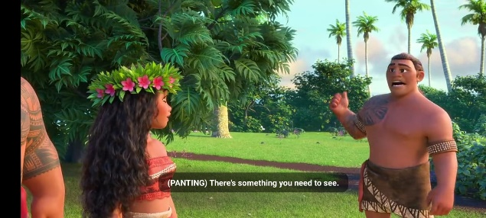

Dialog: “Chief! There’s something you need to see.”

In the sentence at minute 13:49, one of the villagers wants to ask Moana as the new chief to see what has happened in her village. The word “need to” here describes Moana's obligation as the new chief to provide justice and care for the village. If the sentence is changed to “You may take a look at this whenever you want” it will become a permission sentence because of the word “may”, or changed to “You must not ignore this important information” it will become a prohibition sentence because of the word “must not”.

The word expresses Moana's sense of responsibility which illustrates how deontic expression drives the character dynamic of the movie. The phrase “Chief! There's something you need to see” is evidence that Moana has an unwavering sense of confidence as the new leader. It also shows the sense of assertiveness and leadership that continues to develop in the film.

So the sentence falls into the obligation deontic modality category with its character dynamics.

* + **Datum 4: Never**

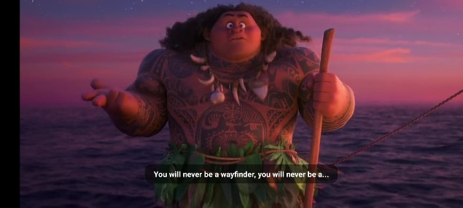

Dialog: “You will never be a wayfinder.”

Deontic expressions shape the character dynamics in Moana that reveal changes in power structures and relationships. Maui's dismissive statement “You will never be a wayfinder” in minutes 52:20 is a prohibition. . If the sentence is changed to “You may choose to pursue other paths and become whatever you want” it will become a permission sentence because of the word “may”, or changed to “You must believe in yourself and explore your potential” it will become an obligation sentence because of the word “must”.

If the context of the film, at first Maui and Moana were always fighting. Maui continues to not want to help Moana because he feels Moana, the daughter of the chief, will never be a wayfinder. It also shows in the word “never”, in Maui's mind, a princess will only sit still and enjoy the power she has. Unlike Moana, who has a high sense of curiosity and learns something new about the vast nature. Moana has shown Maui that she can be a wayfinder. As often as they work together, their collaboration ultimately shows harmonization and having a common goal.

So the sentence falls into the prohibition deontic modality category with its character dynamics.

The percentage that is the result of deontic data analysis is as follows.

**D. CONCLUSION, IMPLICATION, AND RECOMMENDATION**

**1. Conclusion**

In conclusion, in the analysis of deontic modality in the movie Moana. This analysis shows the importance of modality in character development. In this research, the writer obtained four datums related obligation, permission and prohibition based on Palmer’ theory. The writer gets two datum related to obligation which shows the character's responsibility for certain actions or decisions in the word “have to” and “need to” as much as 50%. Then the writer gets two datum related to prohibition which reflects the limitation or existence of rules in the word “can't” and “never” as much as 50%. As for the permission, the writer cannot find the data from the film.

**2. Implication**

Moana film shows how permission, prohibition and obligation are intertwined within one another thus reflecting cultural contexts where individual ambitions meet collective traditions. In addition, this demonstrates the subconscious feature brought about by analyzing media through linguistic means.

For example, during her journey Moana has to balance between personal growth and communal responsibility which are replete throughout culturally-rooted accounts. These insights bring out wider implications for understanding storytelling; not exclusively from linguistic but also anthropological and media perspectives through which deontic modality serves as a point of contact in bridging these approaches.

This study eventually points out a productive route for theoretical progress in the analysis of modality, particularly in cross-cultural media. By exploring deontic modality in movies like Moana, researchers may find out regularities that represent general human experiences but also observe cultural differences. Therefore, deontic modality can be seen as something more than just a language phenomenon; it can also be used to understand cultural storytelling mechanisms in changing media landscape.

**3. Recommendation**

From an educational perspective, this study serves as a valuable resource for teaching linguistic modality through relatable and engaging examples. Popular media like Moana allows educators to bridge abstract theoretical concepts with tangible, real-world applications. By analyzing instances of deontic modality in the film, students can gain insights into how language shapes social interactions, character development, and narrative coherence. This method fosters a deeper understanding of linguistic principles while making lessons more dynamic and accessible.

In the context of screenwriting and filmmaking, the findings illuminate the importance of intentional linguistic choices in crafting dialogues and narratives. Writers can strategically use deontic modality to reflect character relationships, cultural norms, and power dynamics. For instance, Moana’s dialogue often reflects her struggle between adhering to communal expectations and pursuing personal aspirations, a dynamic that resonates universally. Such deliberate use of modality enriches character arcs and enhances audience engagement, making stories more layered and impactful.

Finally, as storytelling increasingly embraces diverse voices, understanding and utilizing linguistic modalities becomes essential for authenticity and cultural representation. Filmmakers and scriptwriters can draw on deontic modality to address nuanced social issues and represent cultural identities with sensitivity. This aligns with the growing demand for narratives that not only entertain but also resonate meaningfully across different audiences. By embedding linguistic precision into storytelling, creators can achieve both artistic and cultural credibility, broadening their impact in global media.

**REFERENCE**

Becker, S. C. (2006). Meaning in Language: An Introduction to Semantics and Pragmatics (review). In *Language* (Vol. 82, Issue 4). https://doi.org/10.1353/lan.2006.0183

Bimbó, K. (2010). Semantics. *Key Terms in Logic*, 90–91. https://doi.org/10.1063/1.3067142

Hansen, J. (2006). The paradoxes of deontic logic: Alive and kicking. *Theoria*, *72*(3), 221–232. https://doi.org/10.1111/j.1755-2567.2006.tb00958.x

Holmström, I. (2019). Teaching a language in another modality: A case study from swedish sign language l2 instruction. *Journal of Language Teaching and Research*, *10*(4), 659–672. https://doi.org/10.17507/jltr.1004.01

Korloi, A., Independent, A. N., Paper, S., In, S., Of, F., Requirements, T. H. E., The, F. O. R., Of, D., Of, M., In, A., & Language, E. (2018). *EPISTEMIC AND DEONTIC MODALITY PREFERENCE THROUGH “ WANNA ” EPISTEMIC AND DEONTIC MODALITY PREFERENCE THROUGH ‘ WANNA .’*

Kreidler, C. (2013). Introducing English Semantics. In *Introducing English Semantics*. https://doi.org/10.4324/9781315886428

Moana Script (2016). Disney Studio. https://www.hotstar.com

Palmer, F. R. (1986). Mood and Modality. Cambridge University Press. https://books.google.co.id/books

Saeed, J. I. (2016). Semantics (4th edition). In *Wiley Blackwell*.

Suhadi, J. (2011). Epistemic Modality and Deontic Modality: Two Sides of a Coin. *Julisa*, *11*(2), 156–179.

Suikkanen, J. (2018). Deontic Modality. *Analysis (United Kingdom)*, *78*(2), 354–363. https://doi.org/10.1093/analys/any015

Taylor, J. R. (2017). Lexical semantics. *The Cambridge Handbook of Cognitive Linguistics*, 246–261. https://doi.org/10.1017/9781316339732.017

Van der Auwera, J. (2012). English Modality: Core, Periphery, and Beyond. Springer. https://www.google.co.id/books/edition/English_Modality/